3/28/2023

Antivirus applications

Installation guide and user guide by Group 3

Contents

Installation for Python environment and the relevant module(Suitable for Windows environment) 2

Installing relevant module for Ubuntu system 10

User guide on running the application in windows environment. 11

# Installation for Python environment and the relevant module(Suitable for Windows environment)

In order to successfully run our application on windows computer you will need to install Python in your computer. Below will be the step-by-step guide to let you know how to download and install a Python environment in your windows

Step one

Go to this website (<https://www.python.org/>)

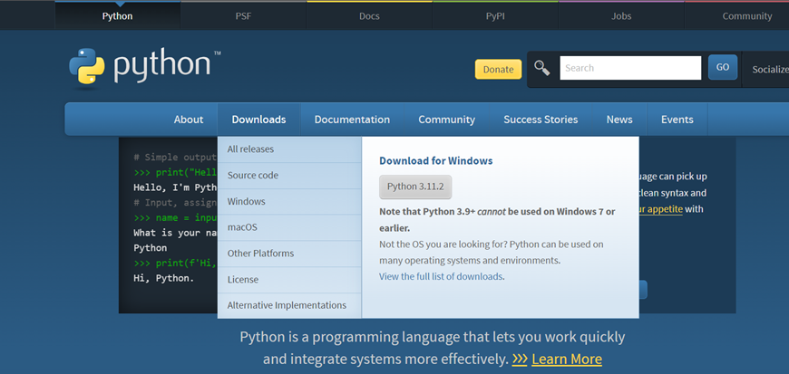

Step 2

Click on the download button!

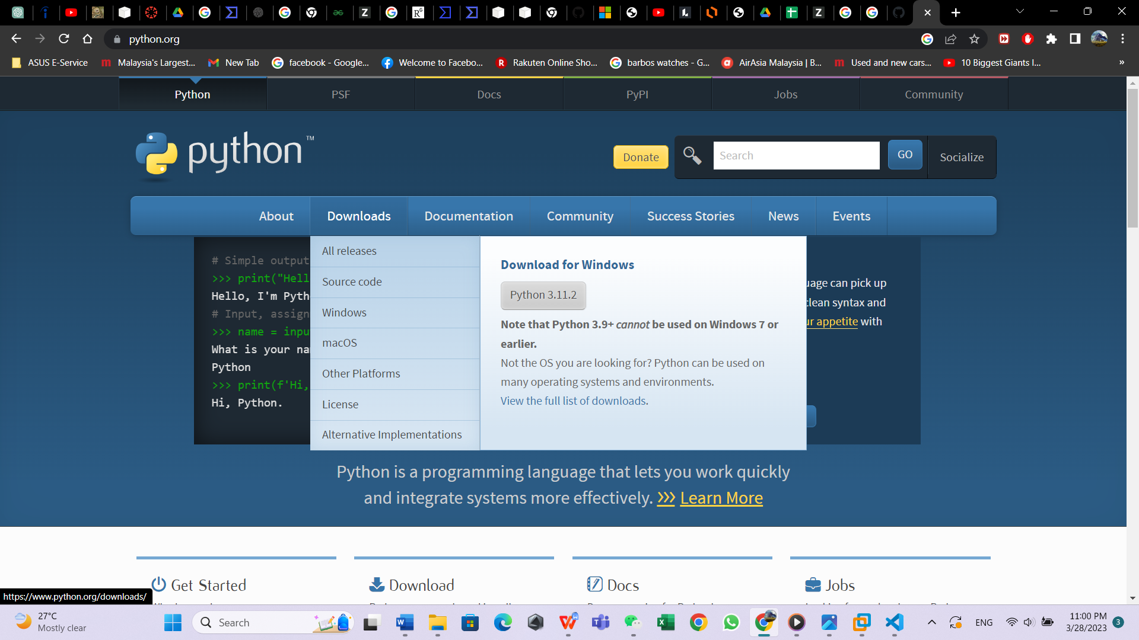

Step 3

Click on the button Python 3.11.2 and make sure it shows (download for Windows)



Step 4

Save and download the installer.

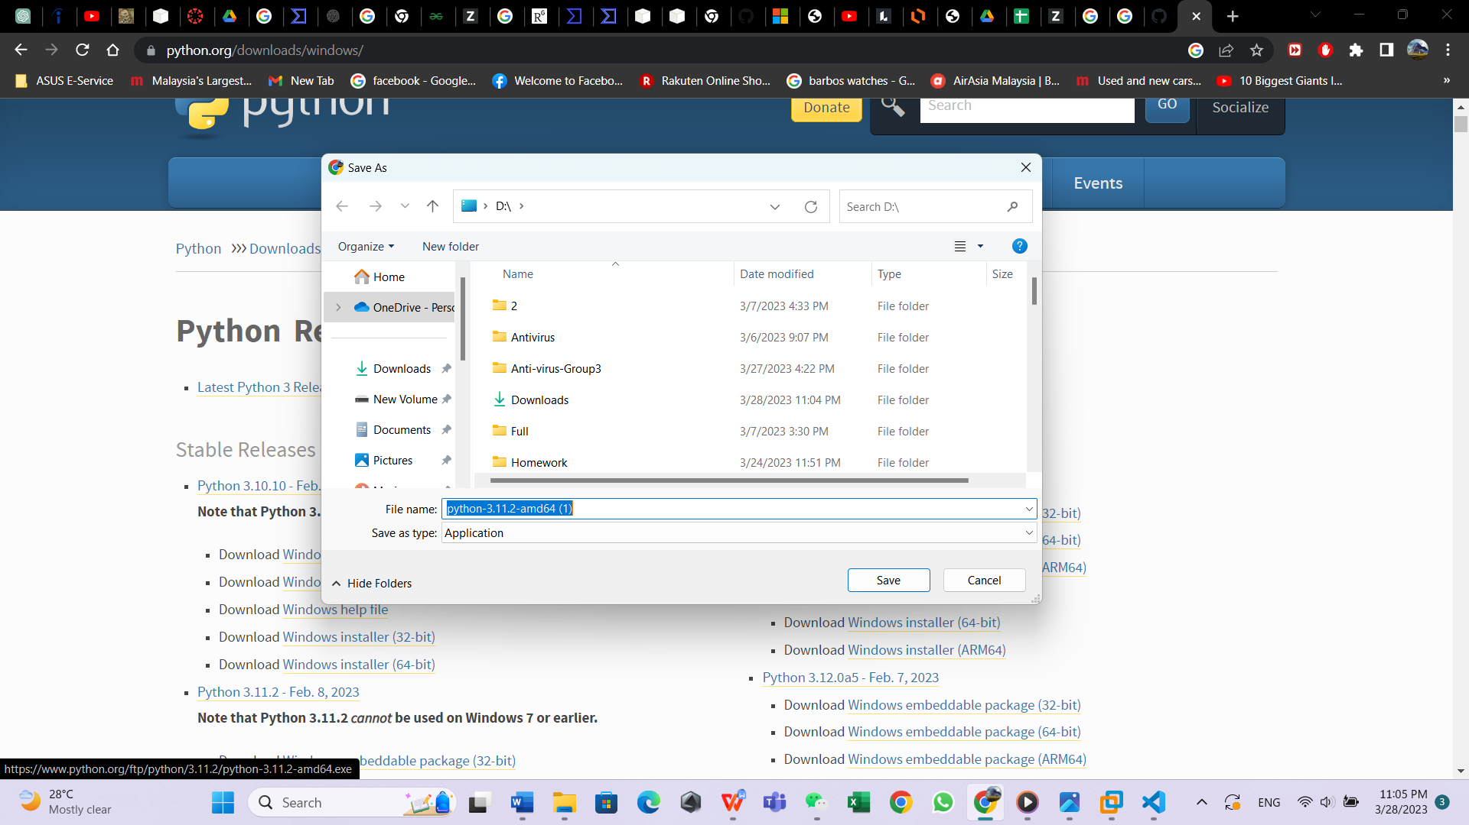

Step 5

Open the installer and you will see the following interface. And make sure you have click on the add python.exe to path

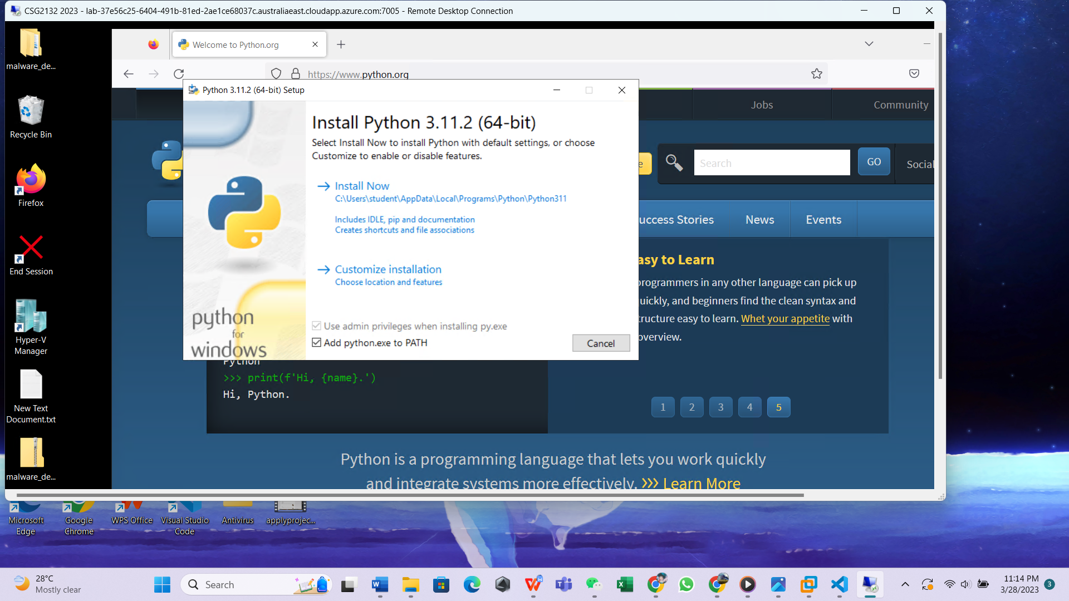

Step 6

Click the customize installations and tick all the check box lastly click the button next

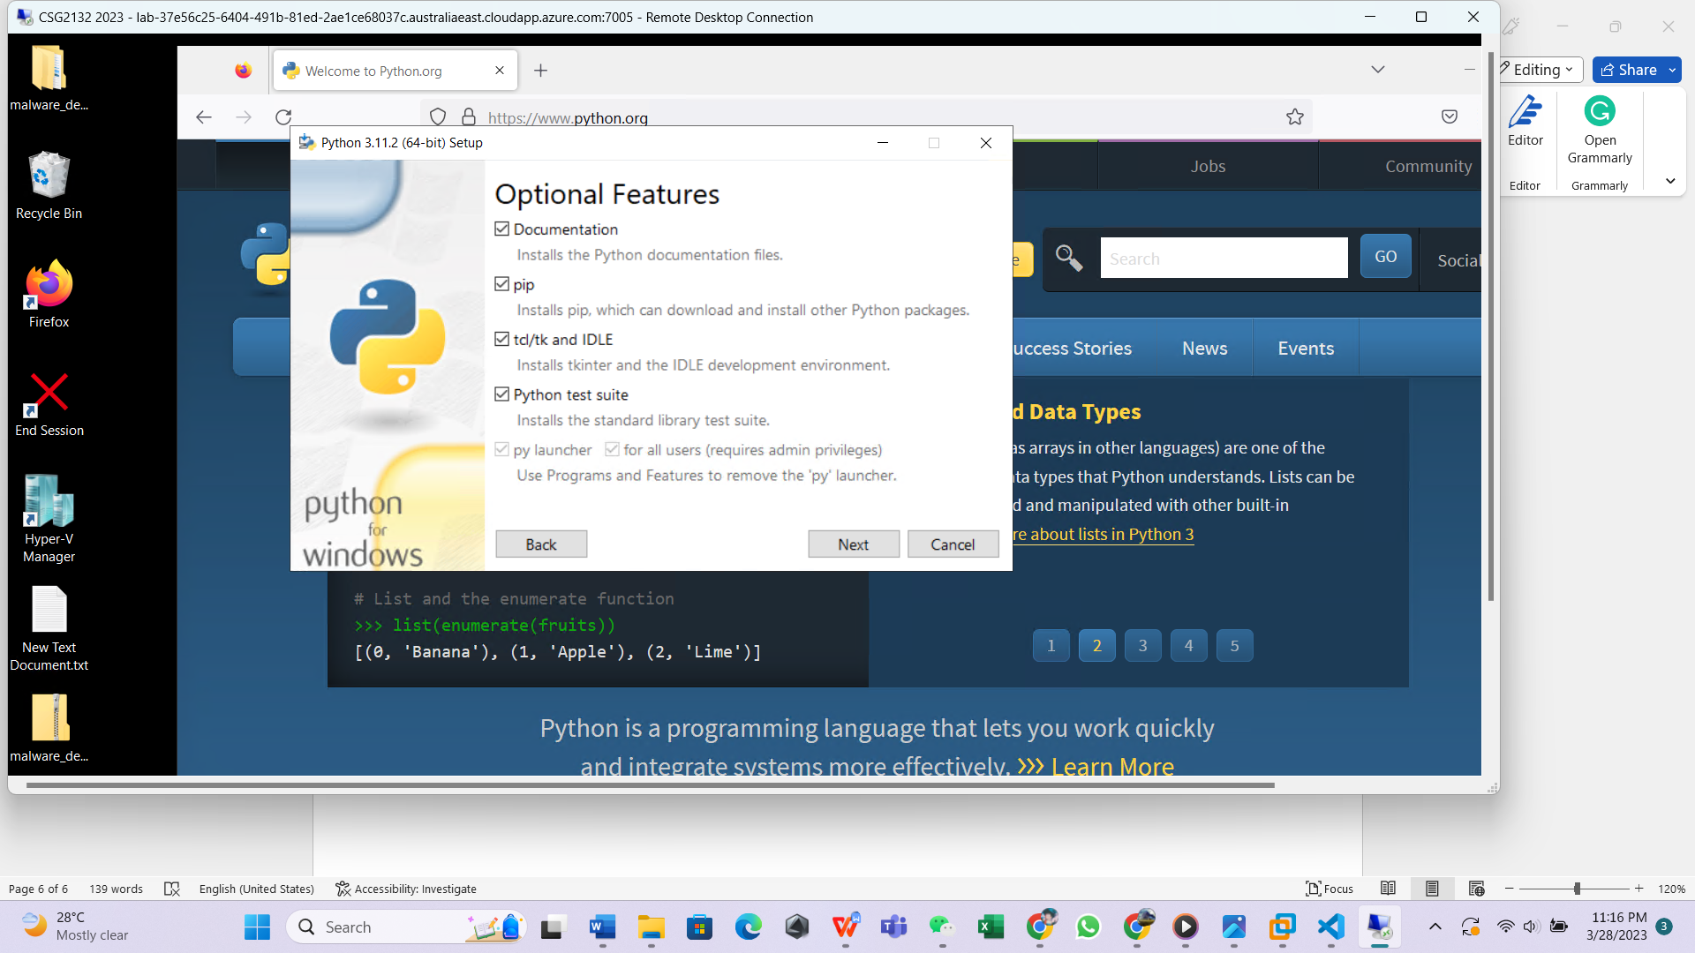

Step 7

Click on all the checkbox to ensure everything is selected and then click the install button

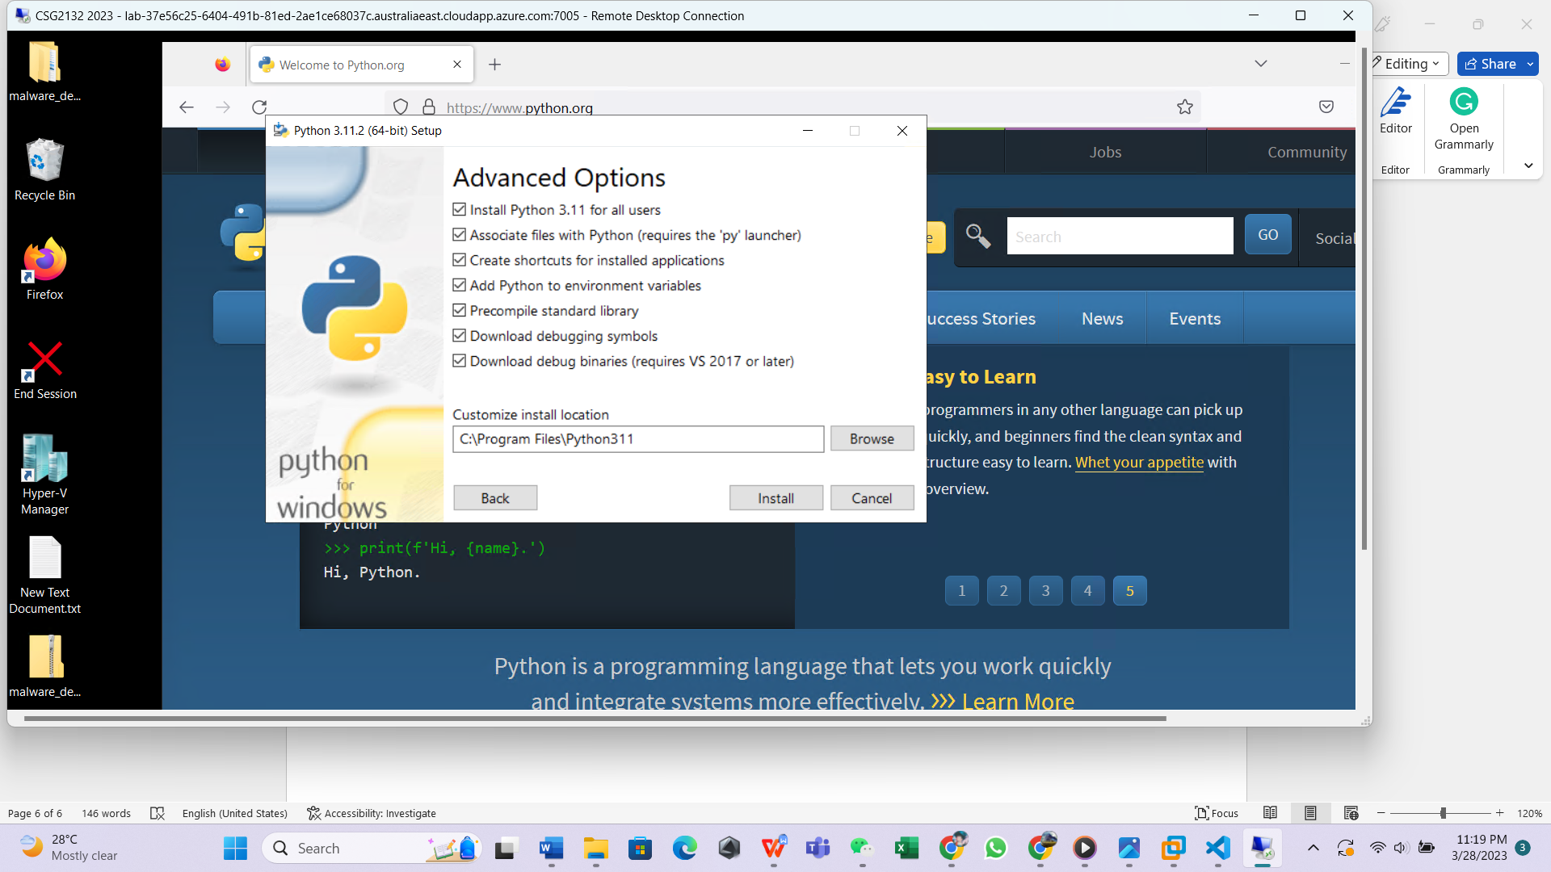

Step 8

Wait for the installation to be completed.

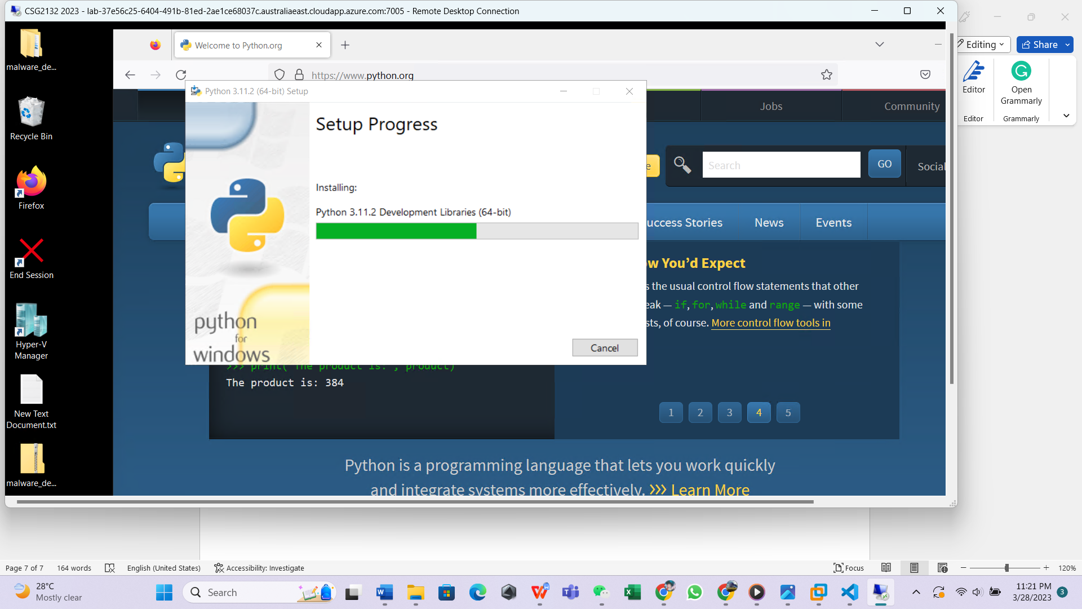

Step 9

After completing the installation close the interface

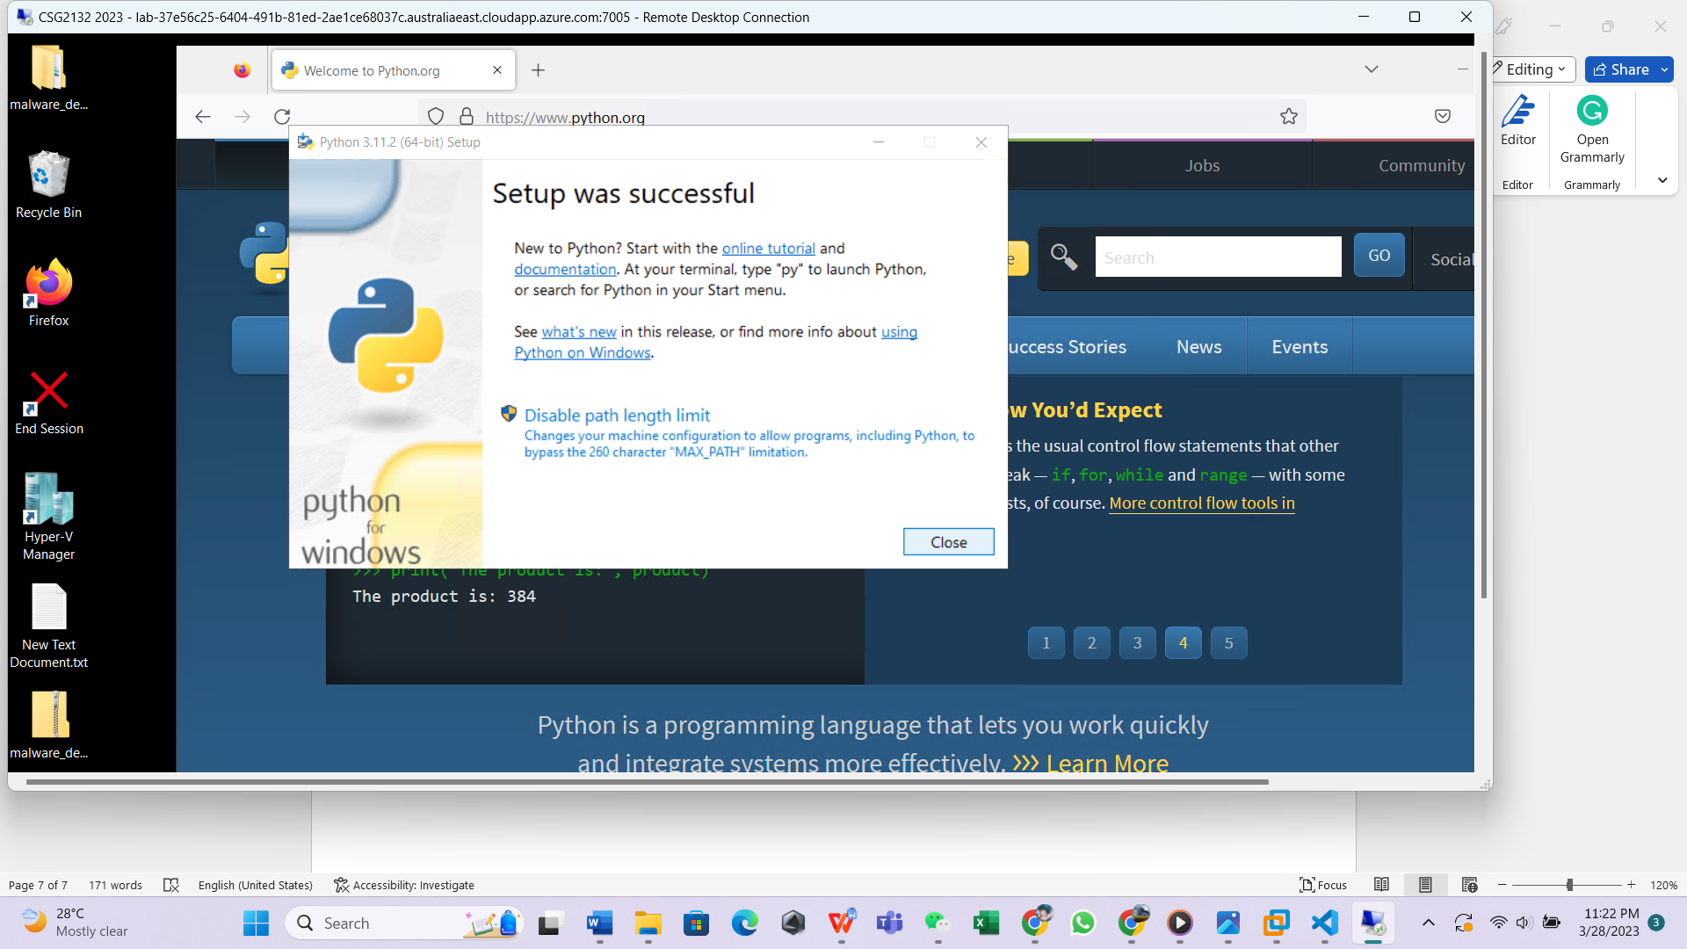

Step 10

Check if the Python is available on your windows computer

Press the window key and R at the same time.



A small dialog box will pop up at the below of your screen

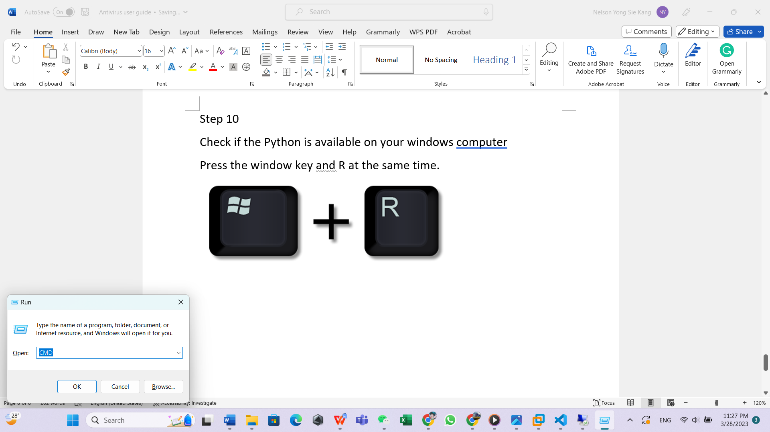

Type in( CMD ) into the dialog box



A command prompt like this will pop up on your screen

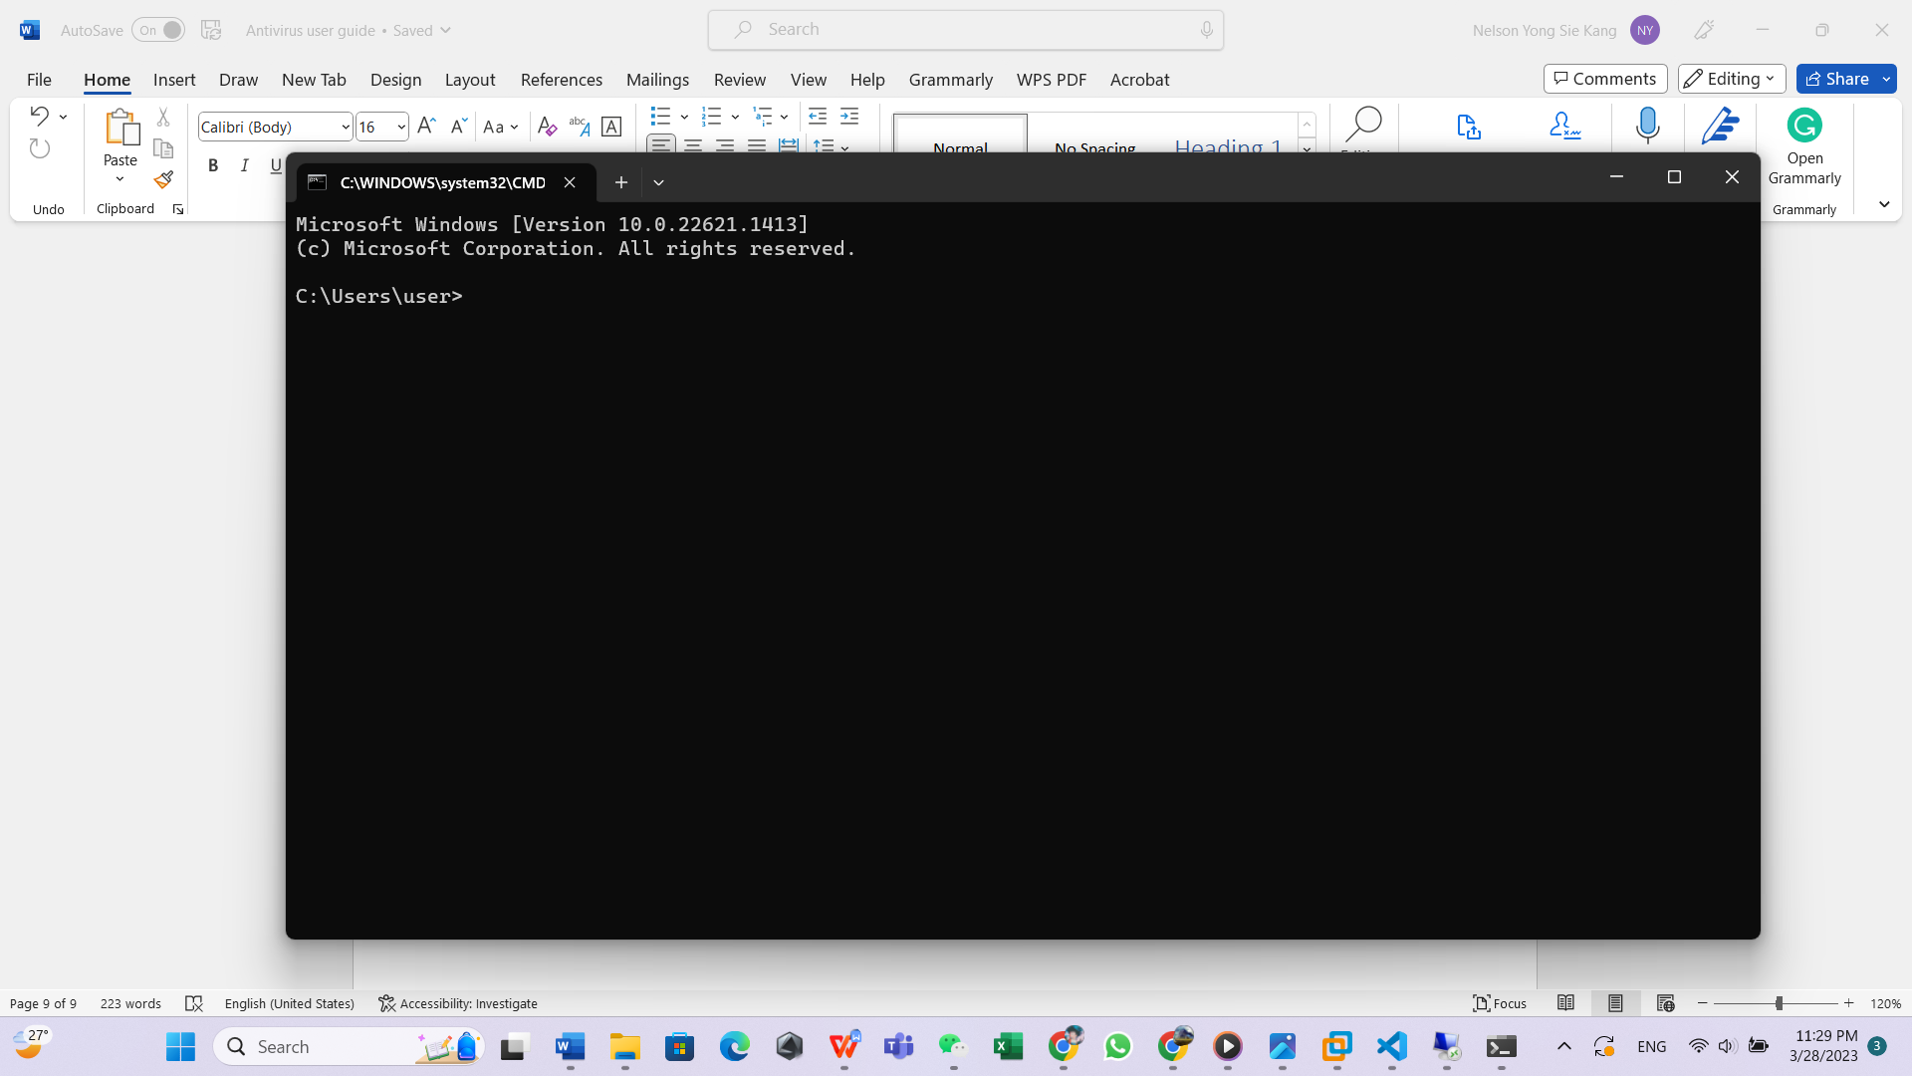

Type in the command ( python --version) or ( py –version)

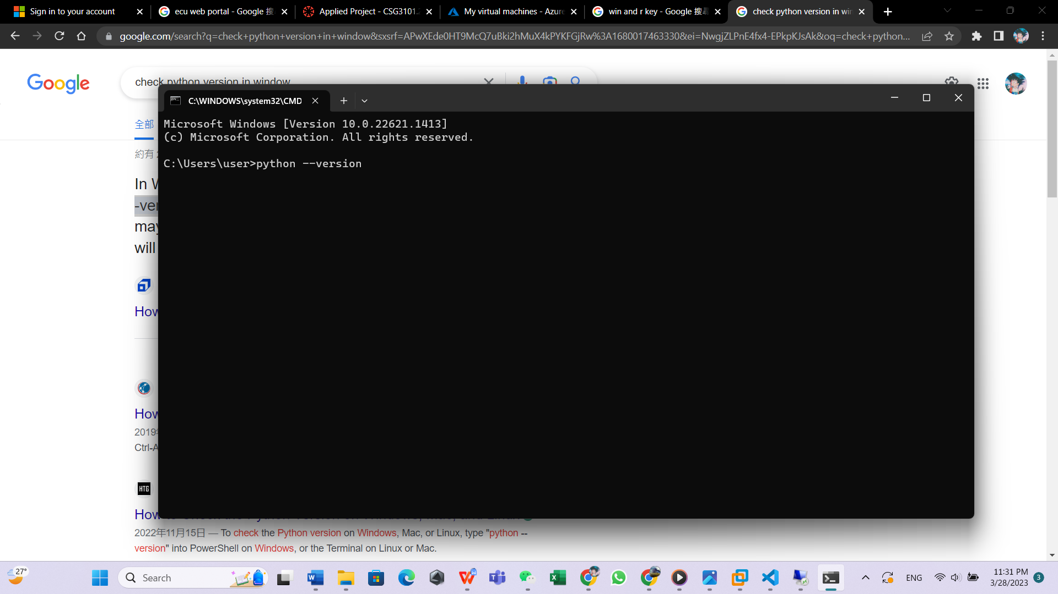

And a Python version will be displayed on the command prompt meaning that python environment is installed in your computer.

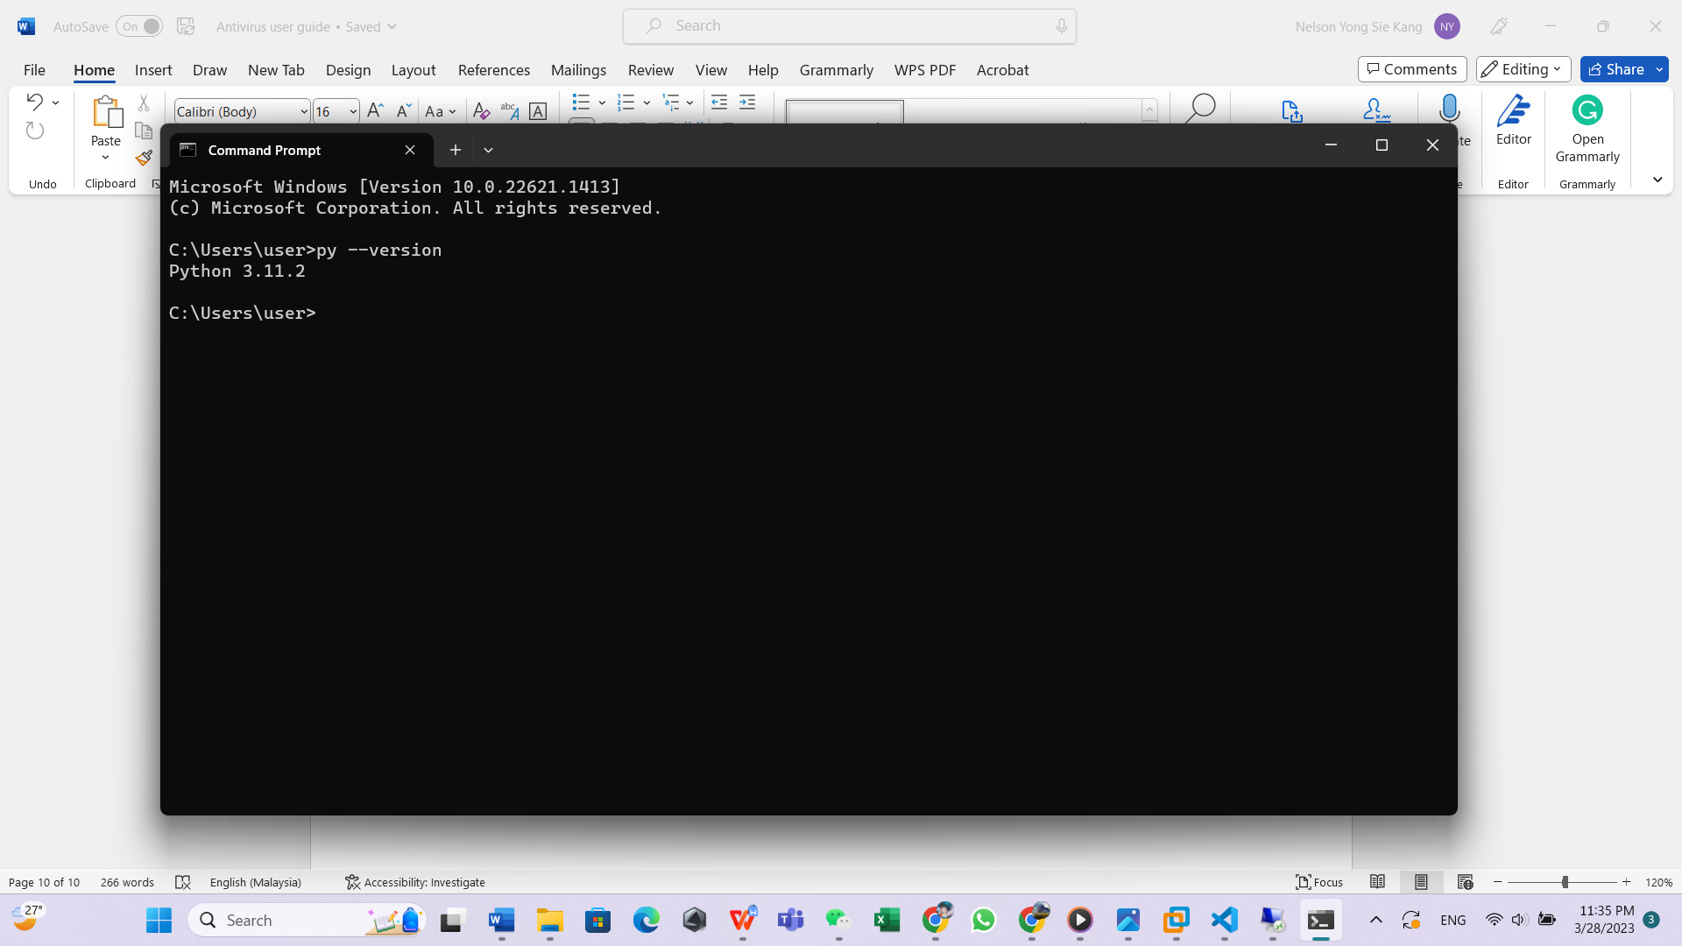

Next we will install the critical module in order to run our antivirus application

Type in (py -m pip install virustotal-api) in the same command prompt and press enter

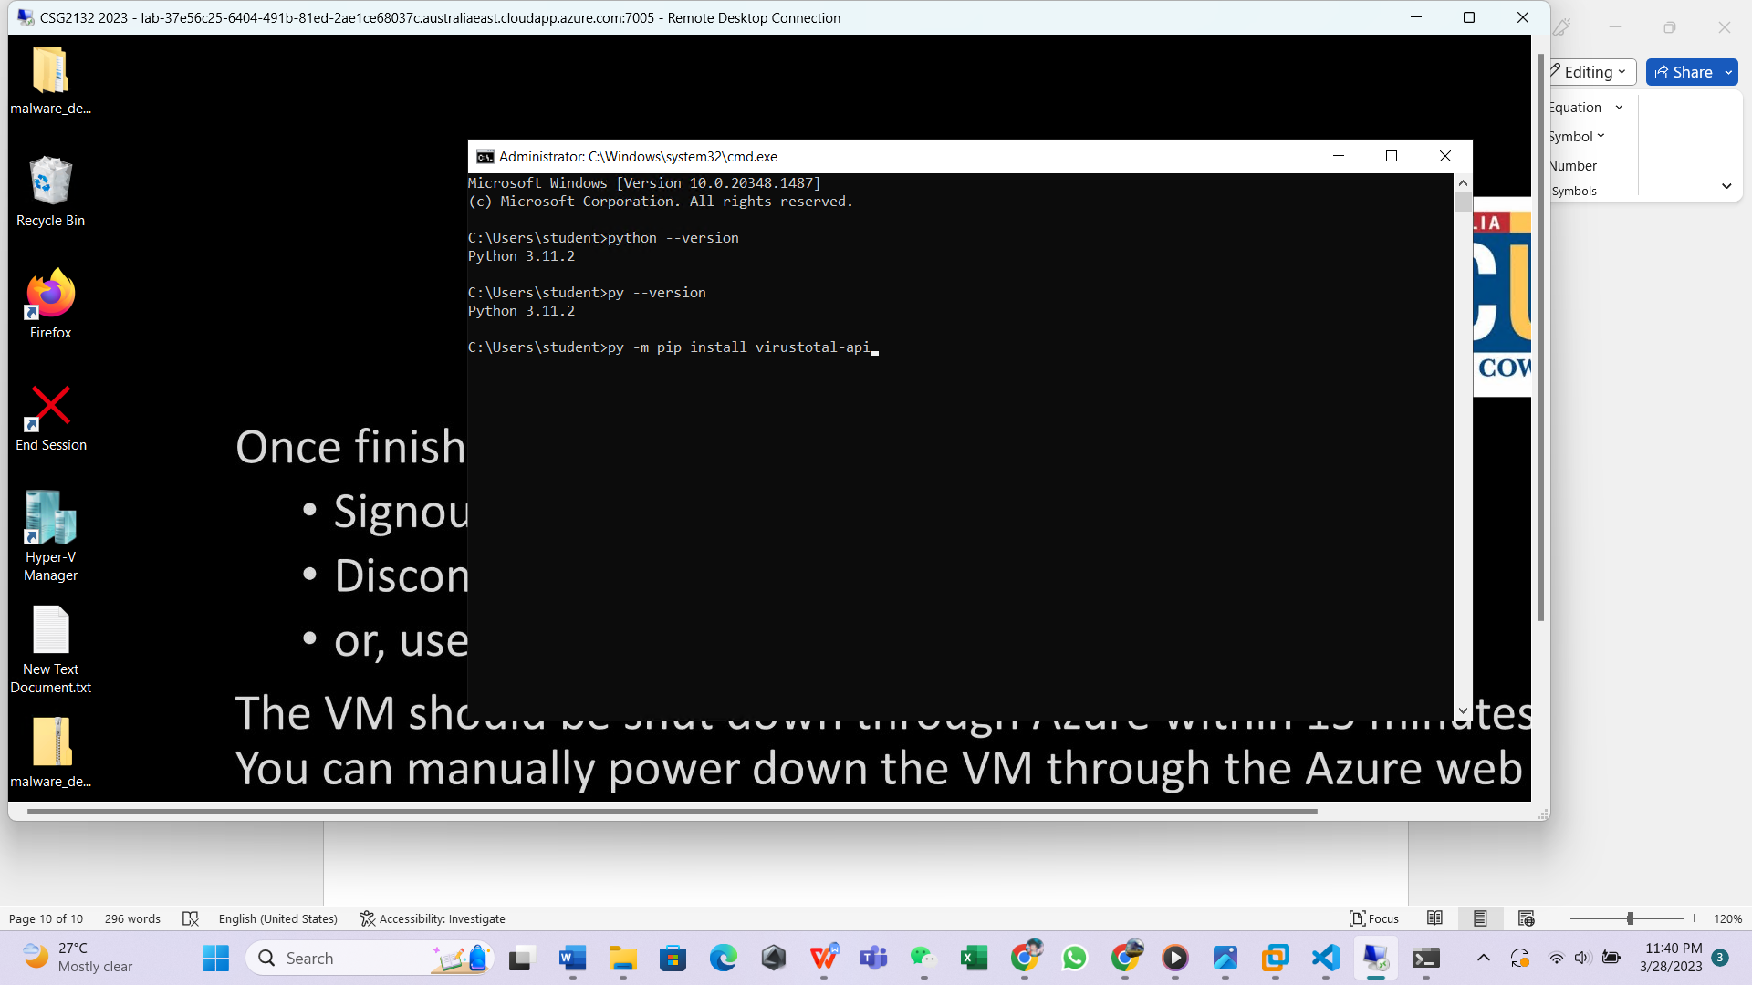

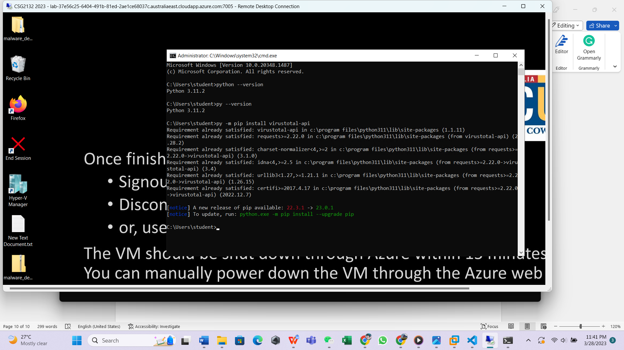You will see that it will start to install the relevant module, wait for it to complete and close the command prompt.

Now that you have successfully installed older requirement modules and environment in your windows computer in order to run the application.

# Installing relevant module for Ubuntu system

Ubuntu system have integrated Python environment within itself so there is no need for installing Python again but still there were relevant Python module needs to be installed in order to run the applications

Below will be the guides on installing the Python module

Step one

open the terminal on your Ubuntu machine

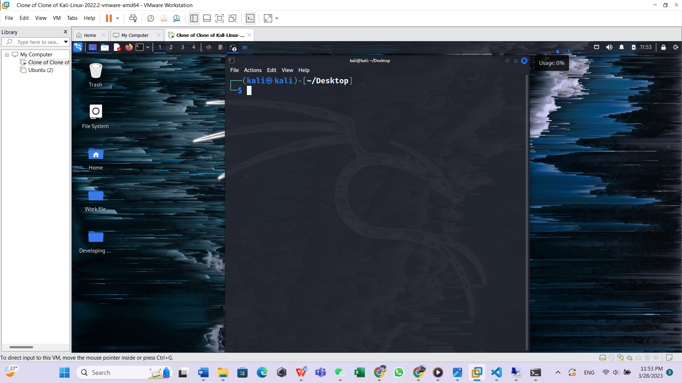

Step two

type the following commands (pip install virustotal-api) into the terminals and press enter

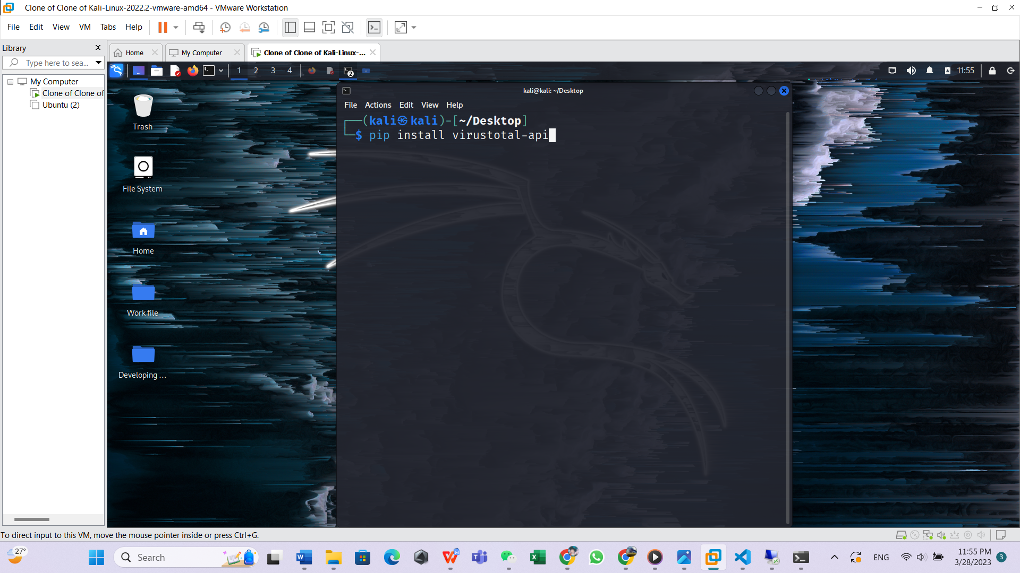

Step 3

Wait for the installation to be completed and close the terminal.

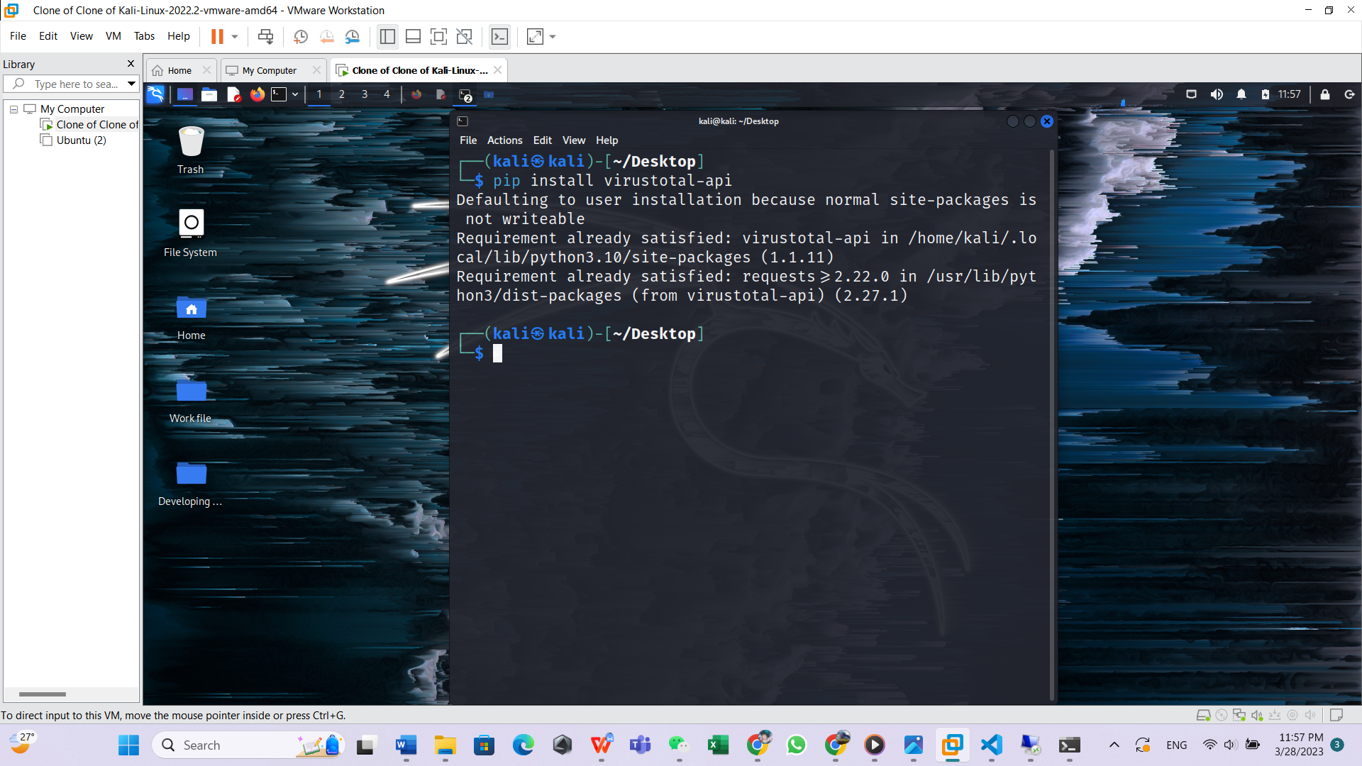

Now that you have successfully installed the crucial module in order to run the antivirus applications.

# User guide on running the application in windows environment.

Step one

Firstly, download our applications from the GitHub website (<https://github.com/TT-cyberman/Anti-virus-Group3>)

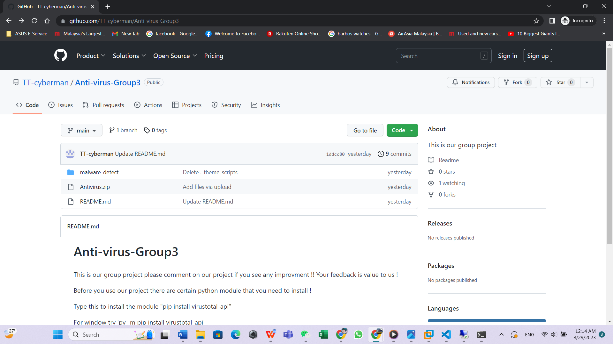

Step 2

Download the zip folder which contain all of the necessary files of our applications.



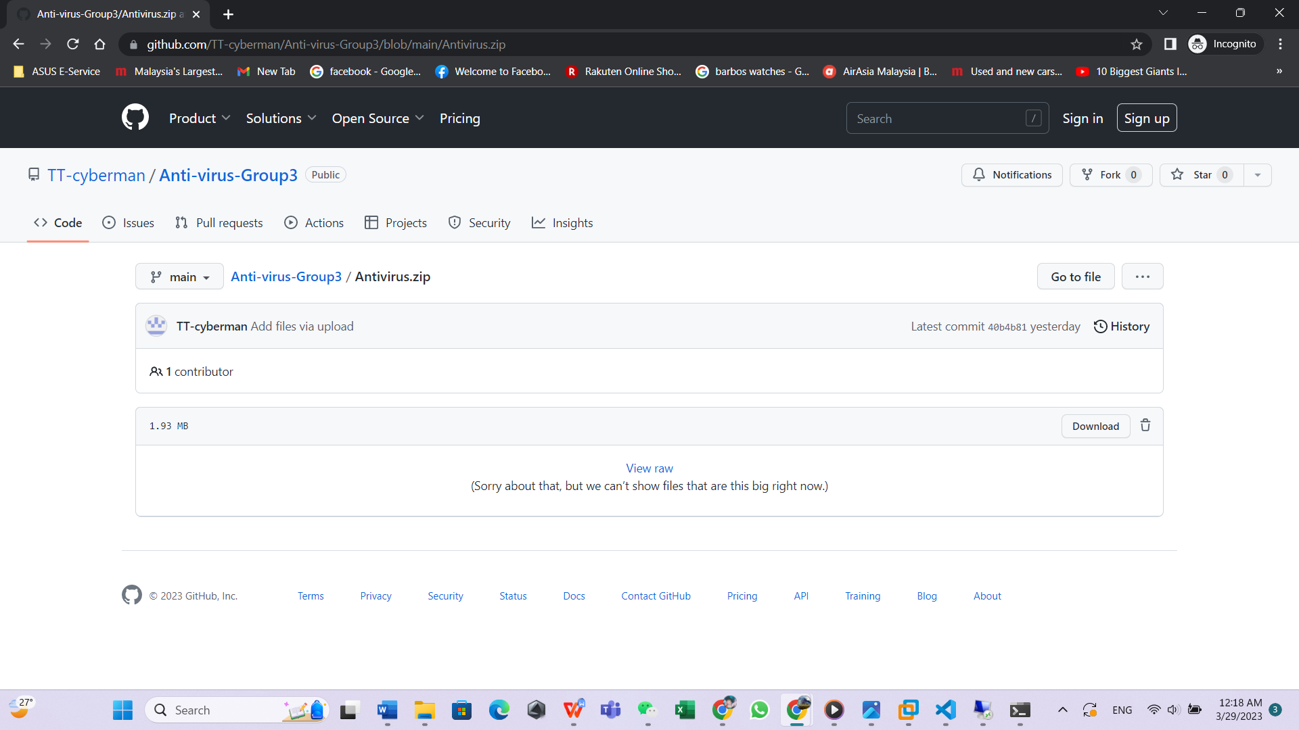

Step 3

Download the zip file and save it on your desktop in my case is new value D

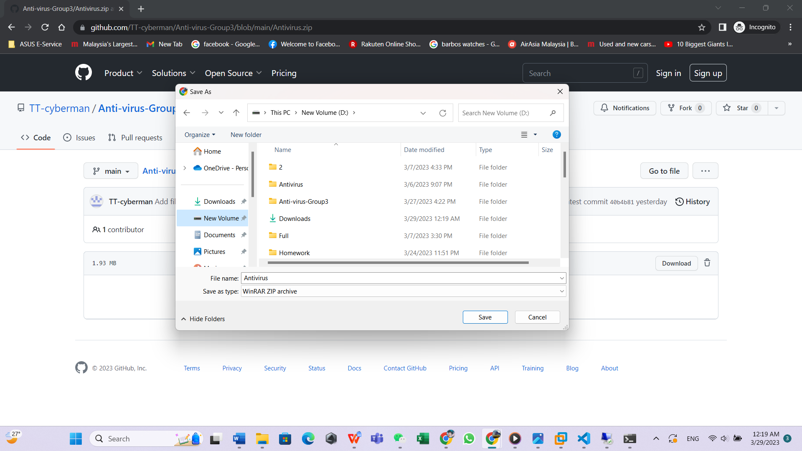

Step 4

locate the file that you just downloaded and unzip it



Step 5

Click open the file then click inside the subfolder and to ensure everything that show in this picture is what you have in your computer.

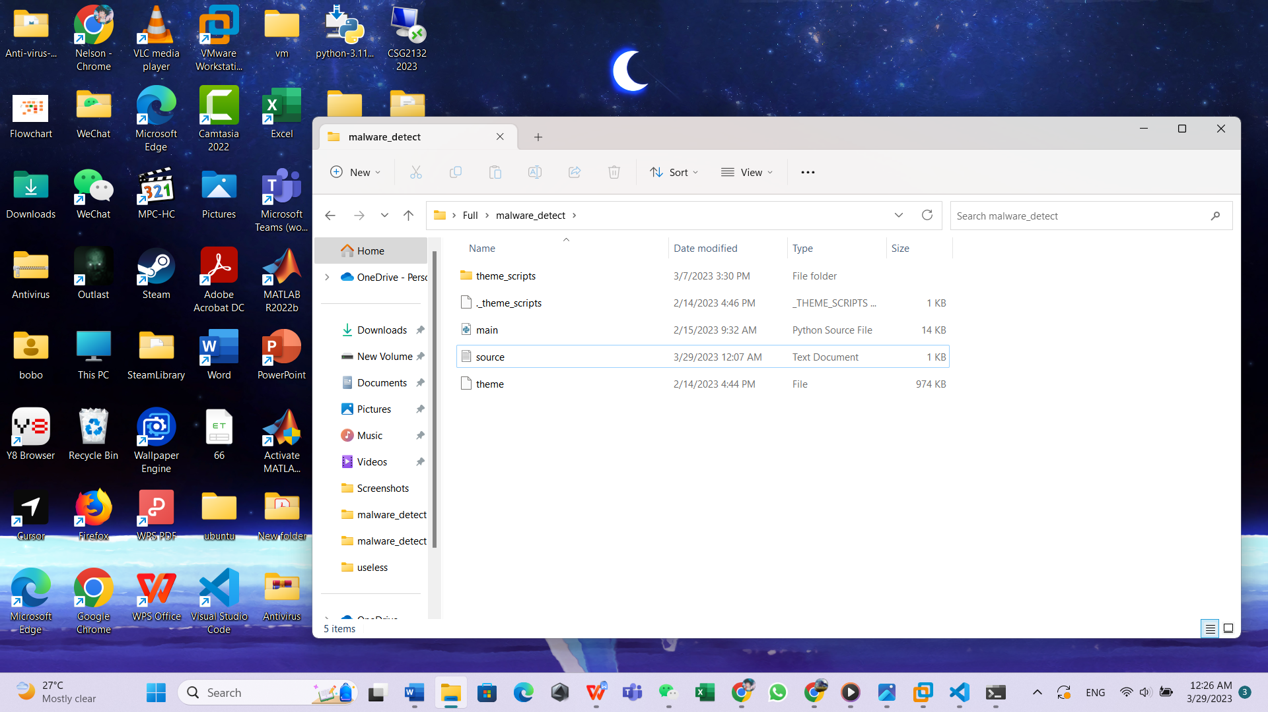

Step 6

using the win key and R to open the command prompt.

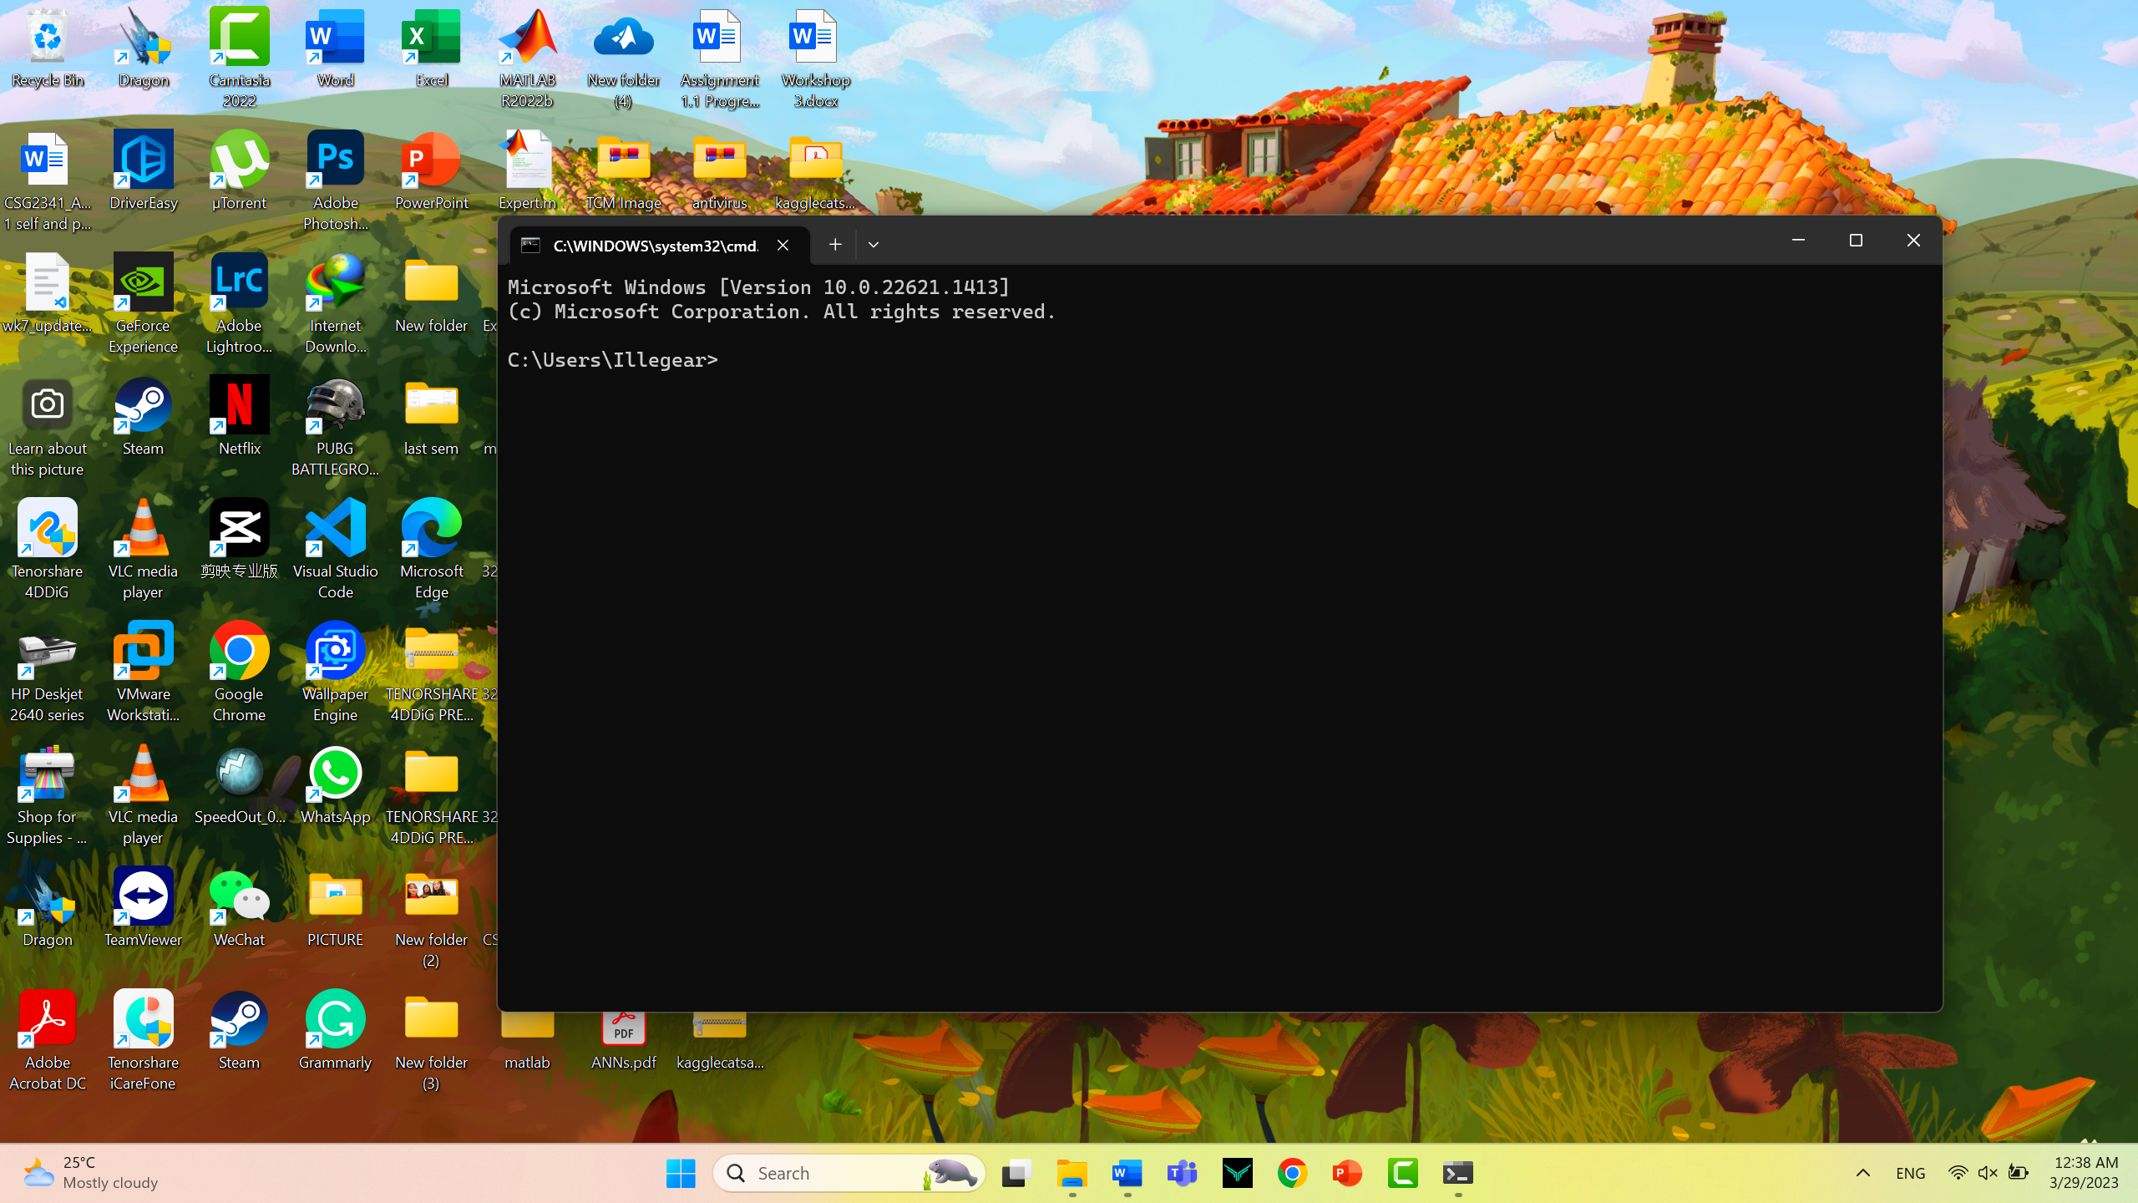

Step 7

Go back to the folder just now and click on the path, then copy down the path

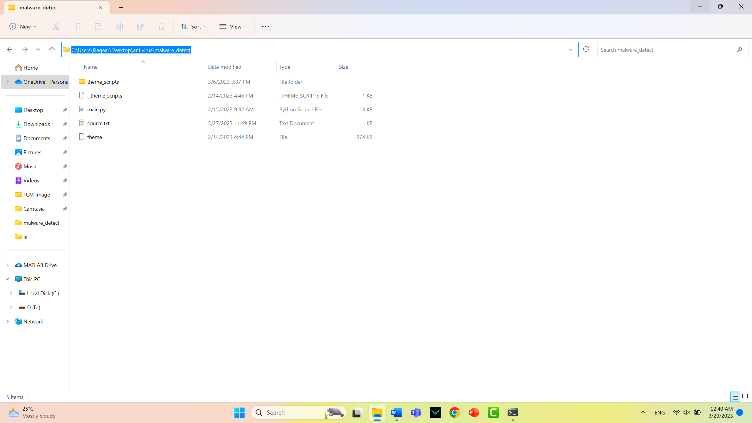

Step 8

Now go back to the command prompt just now and type (cd )

Then leave one space lastly paste down the path that you copy just now.

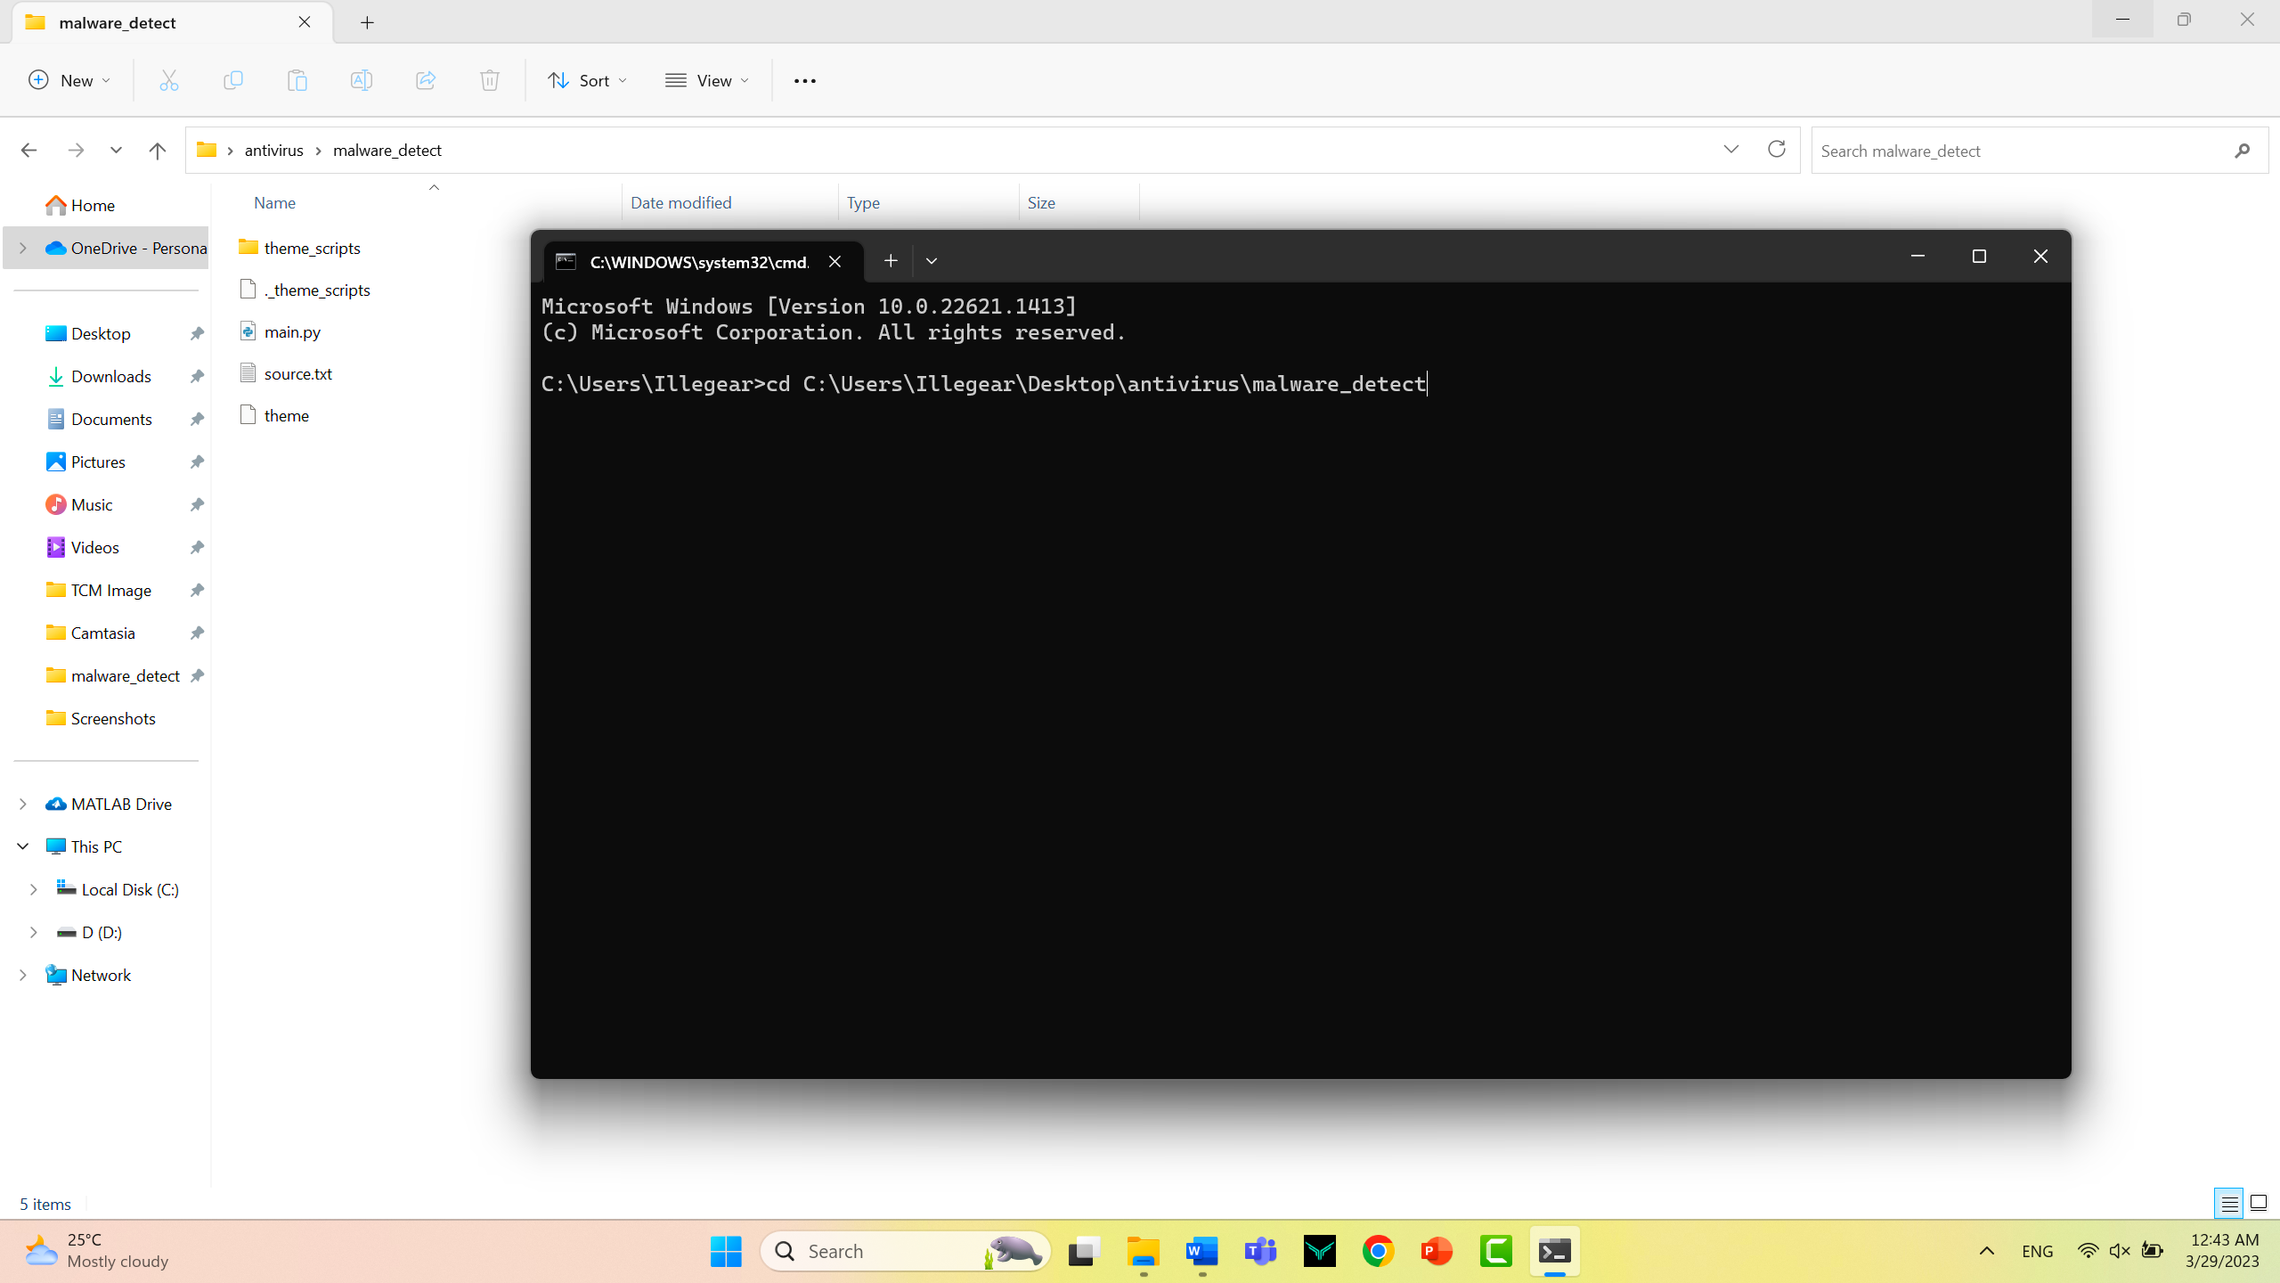

Press enter

Step 9

Now that you are successfully located inside the folder

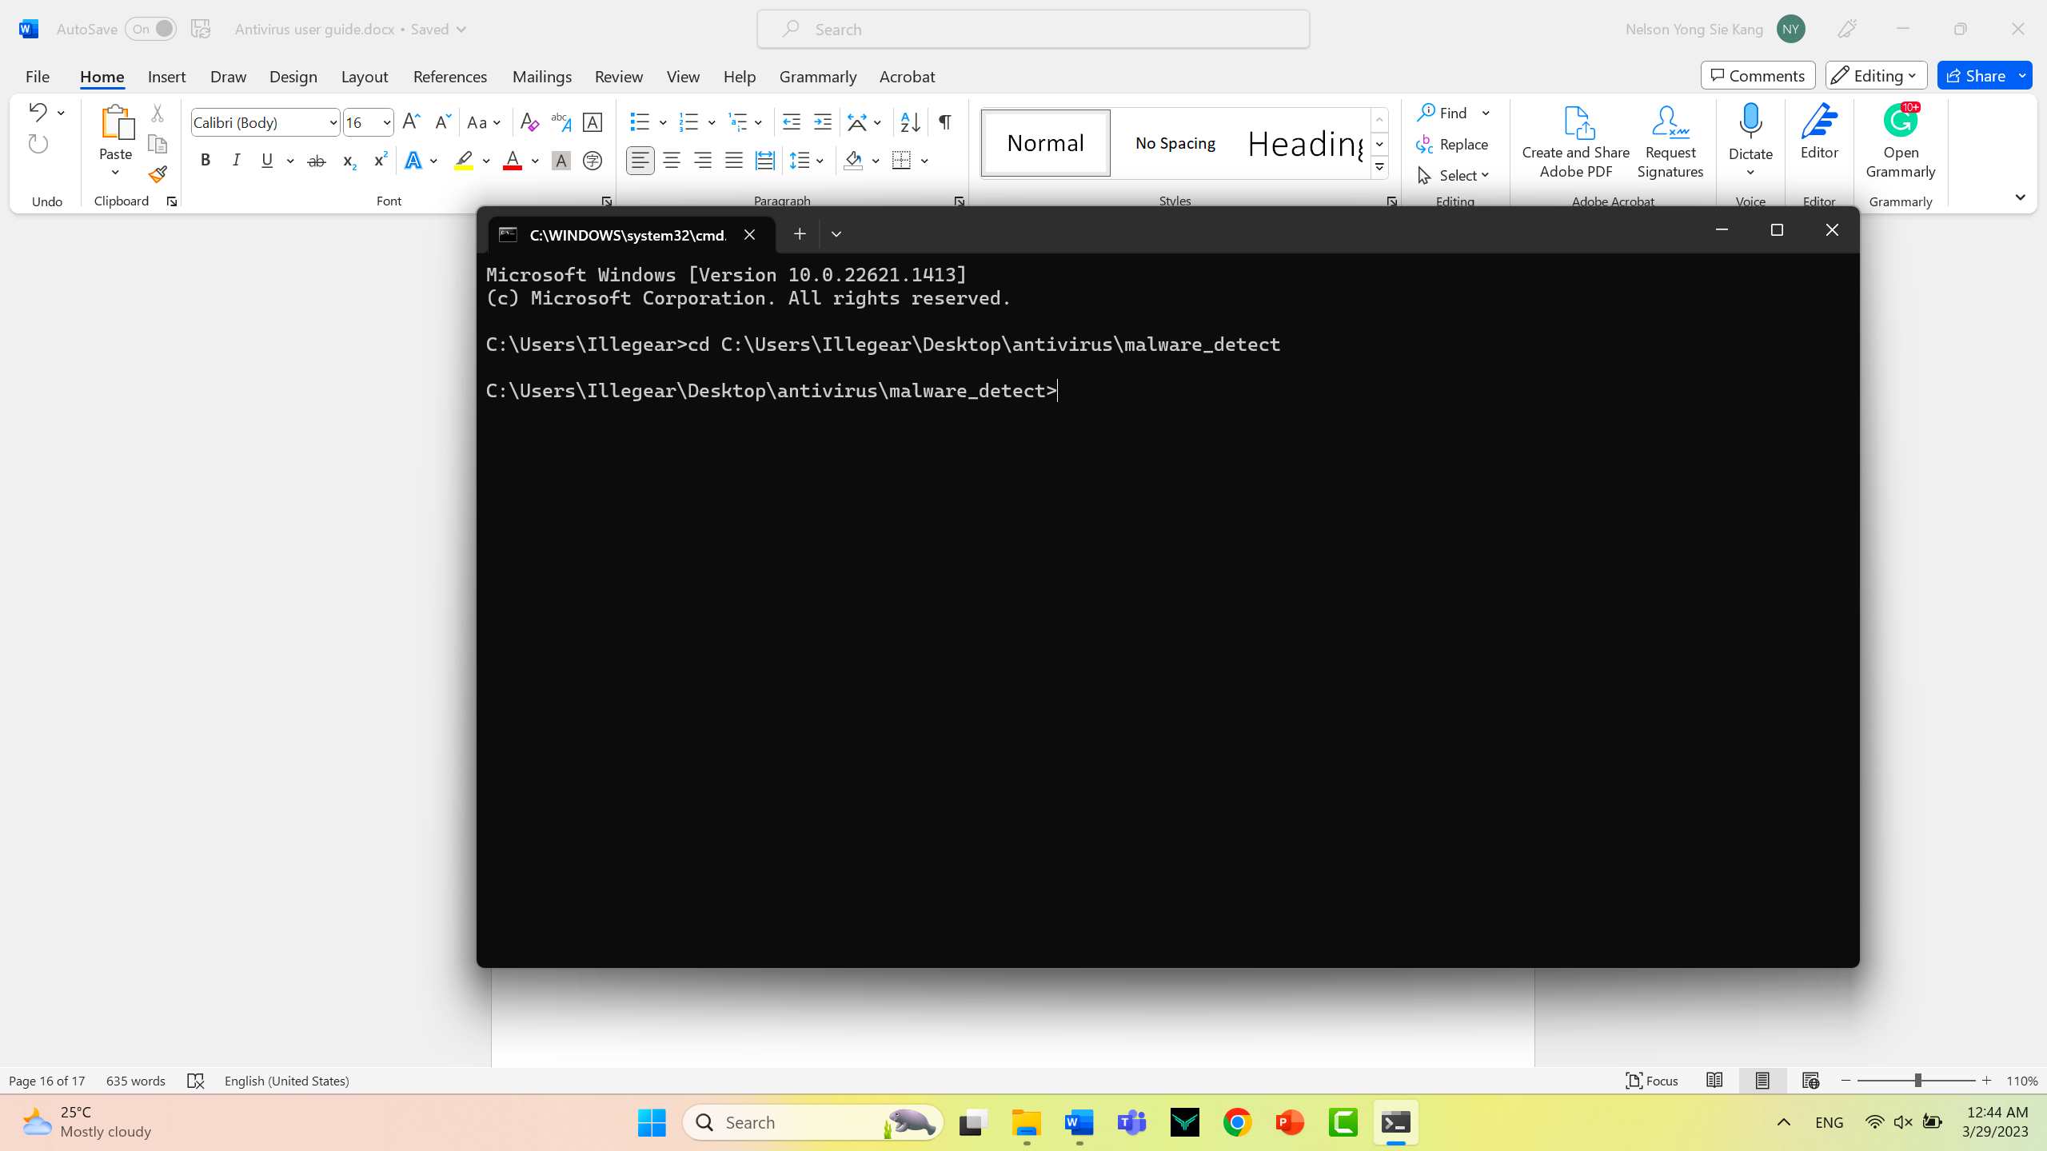

Step 10

Now you can copy paste and he found that you wanted to scan for virus into the folder just now, in my situation I wanted to scan this installer to check whether that it has been flagged as a malicious software

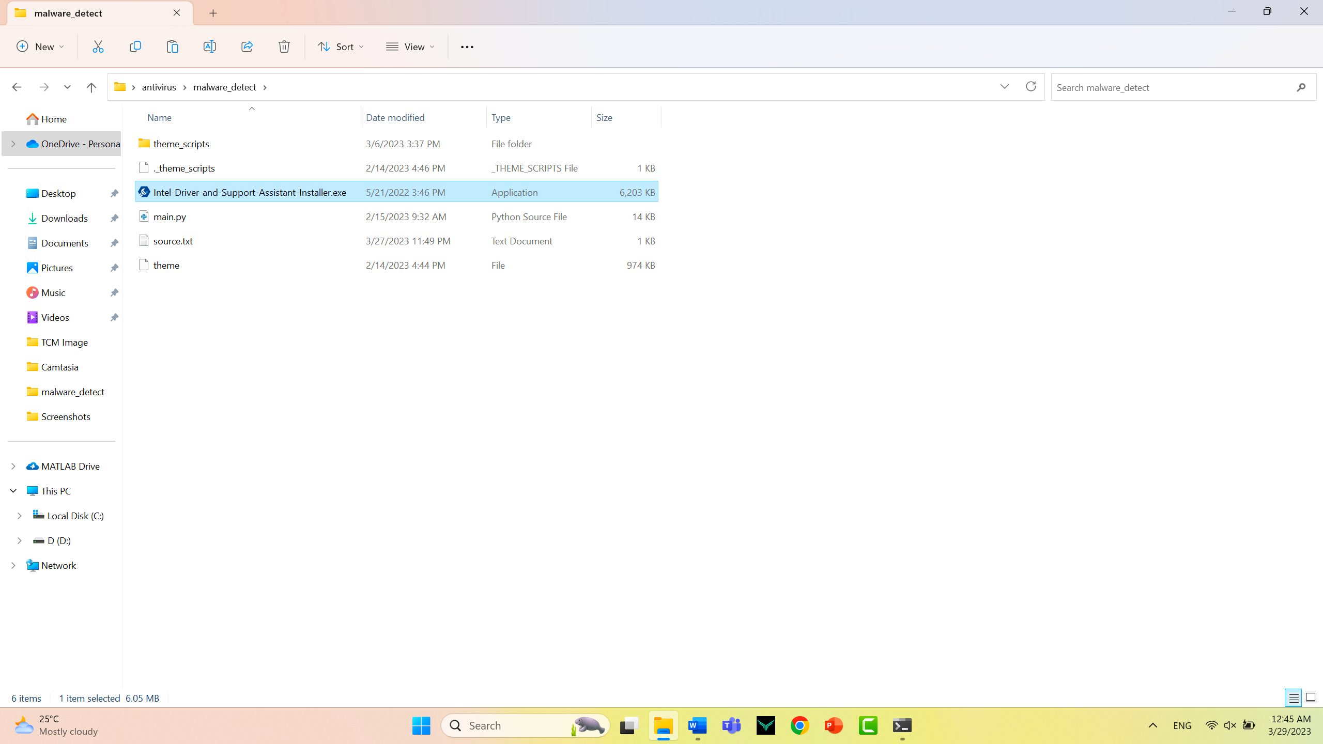

Step 11

now go back to the command prompt just now and type the command (dir) then press enter

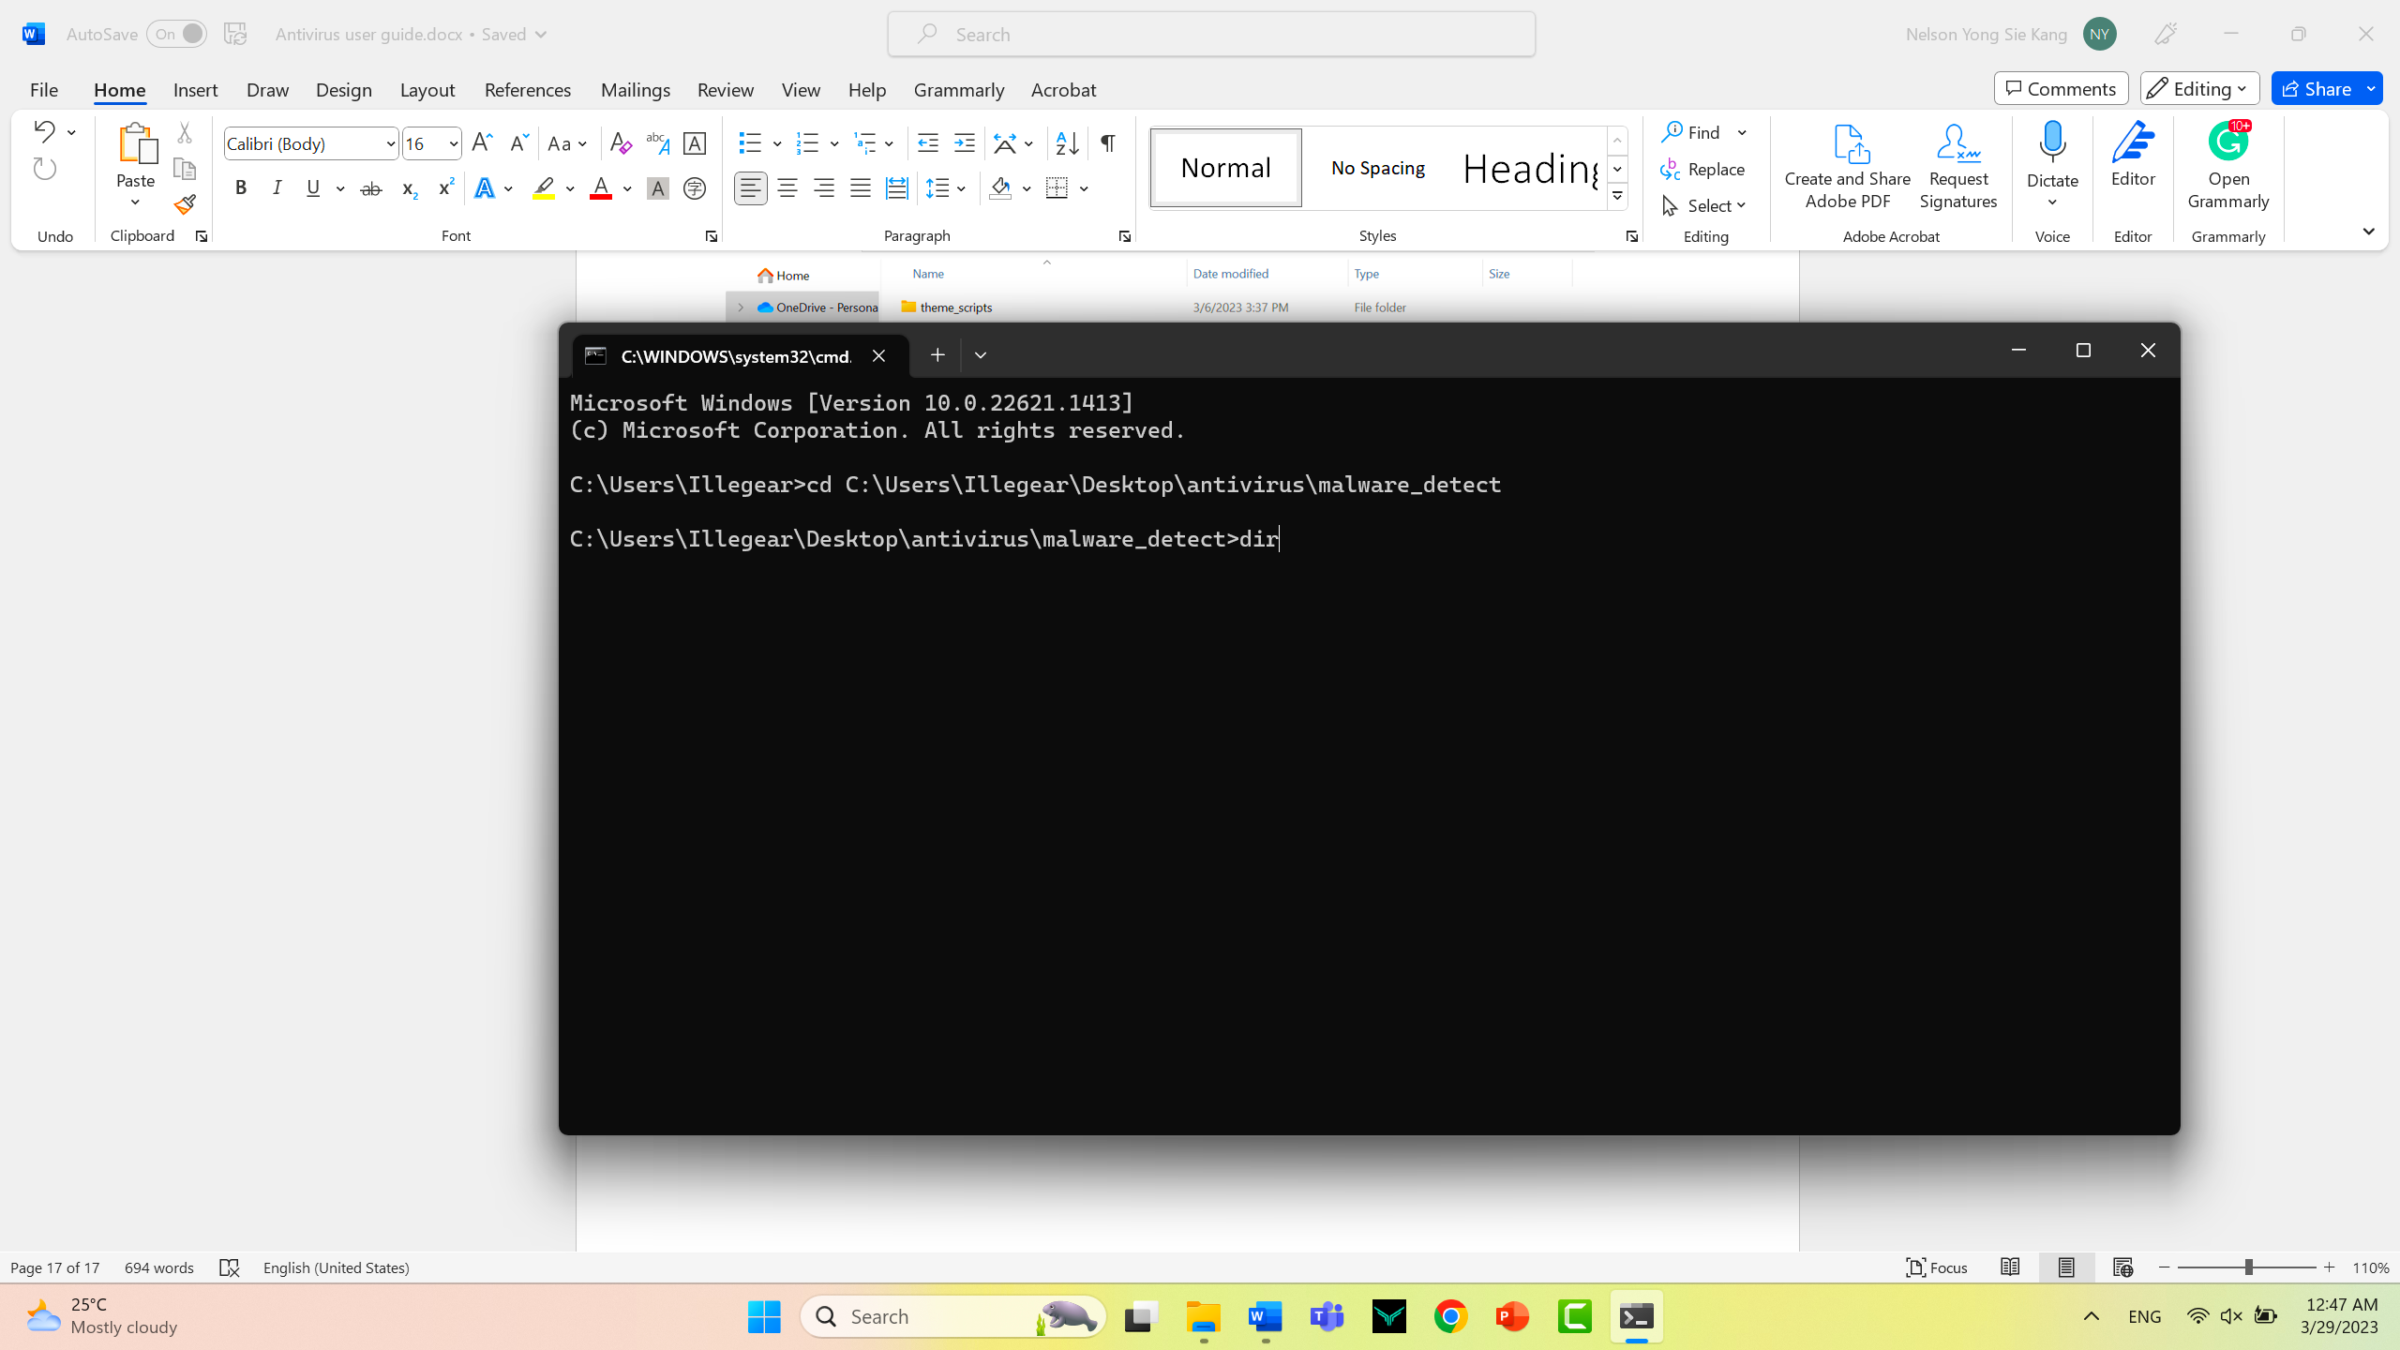

Step 12

Now it should be showing the following interface

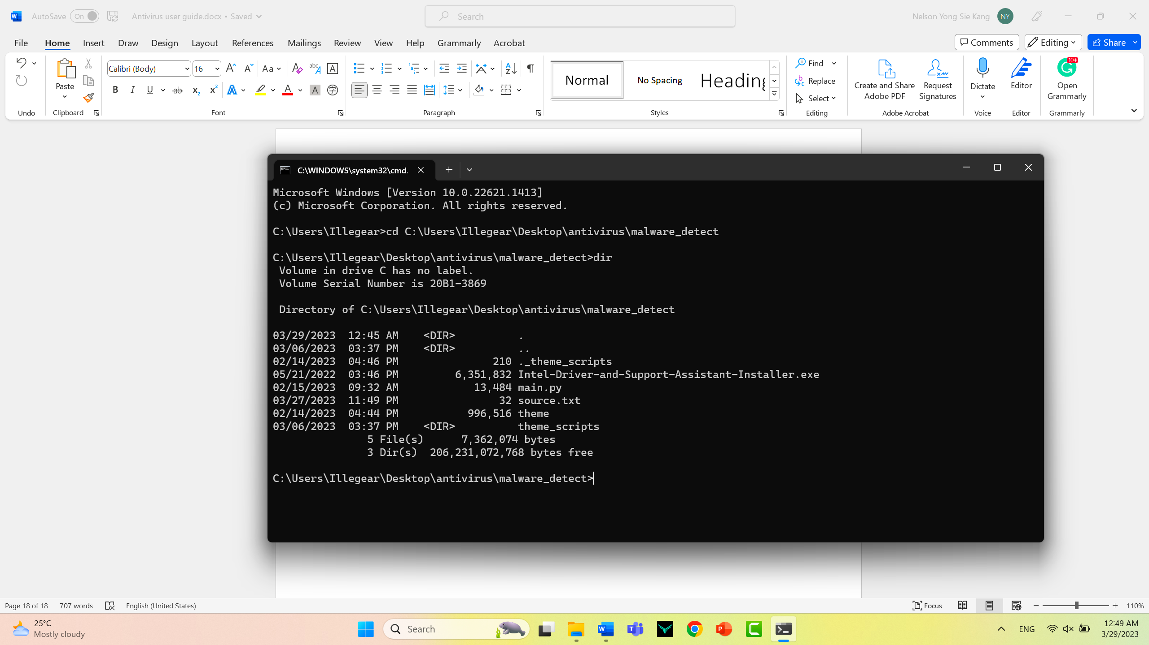

Step 13

now we can start to use our application to scan the file to check whether it has been flipped as malicious software

Firstly you will need to select the name file then use the key (CTRL + C) to copy down the file name in my case it would be (Intel-Driver-and-Support-Assistant-Installer.exe)

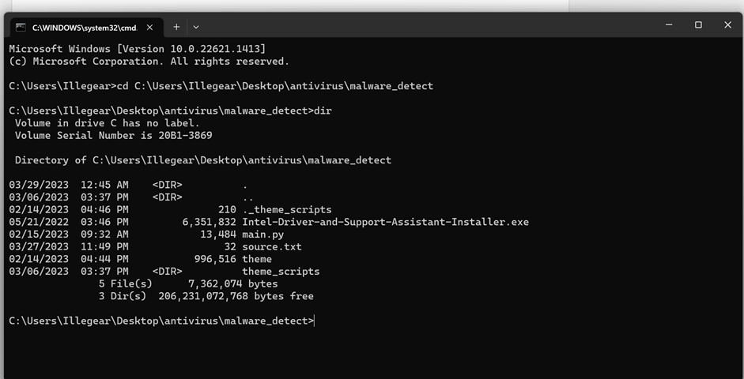

Step 14

In the same command prompt interface type (py ) then space followed by the main function of our antivirus (main.py) the space

then you can copy the entire file name of the file you wanted to scan in my situation it will be (Intel-Driver-and-Support-Assistant-Installer.exe)

then paste it after the (main.py) below will be the example of the code.

(py main.py Intel-Driver-and-Support-Assistant-Installer.exe)

For your situations the (Intel-Driver-and-Support-Assistant-Installer.exe) name extension may be different on you,

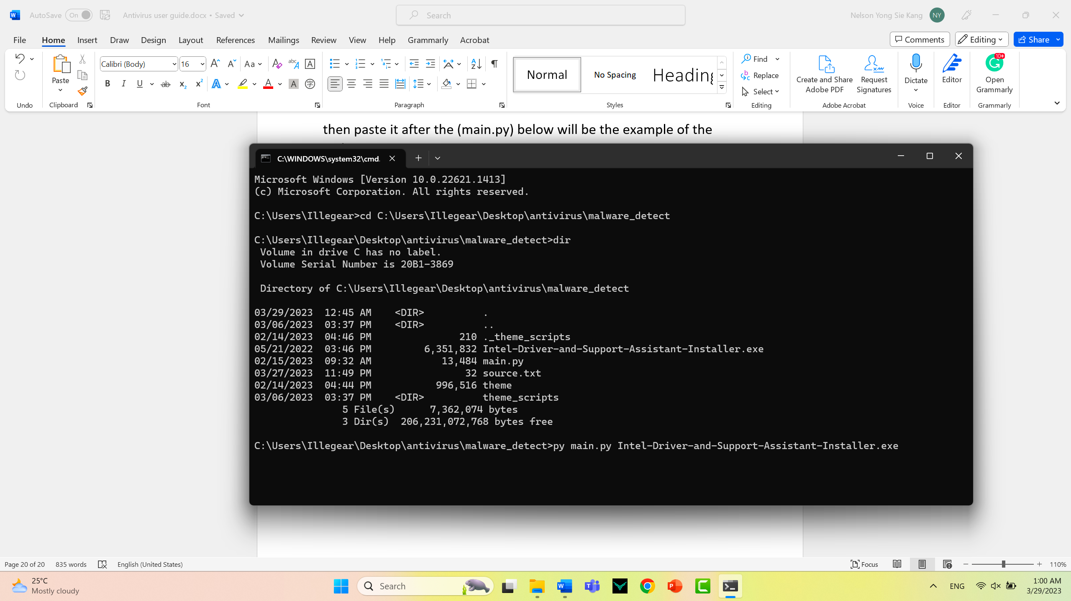

Step 15

After you finishing typing the commands press enter end the application will start to scan for virus and it should be showing the following interface

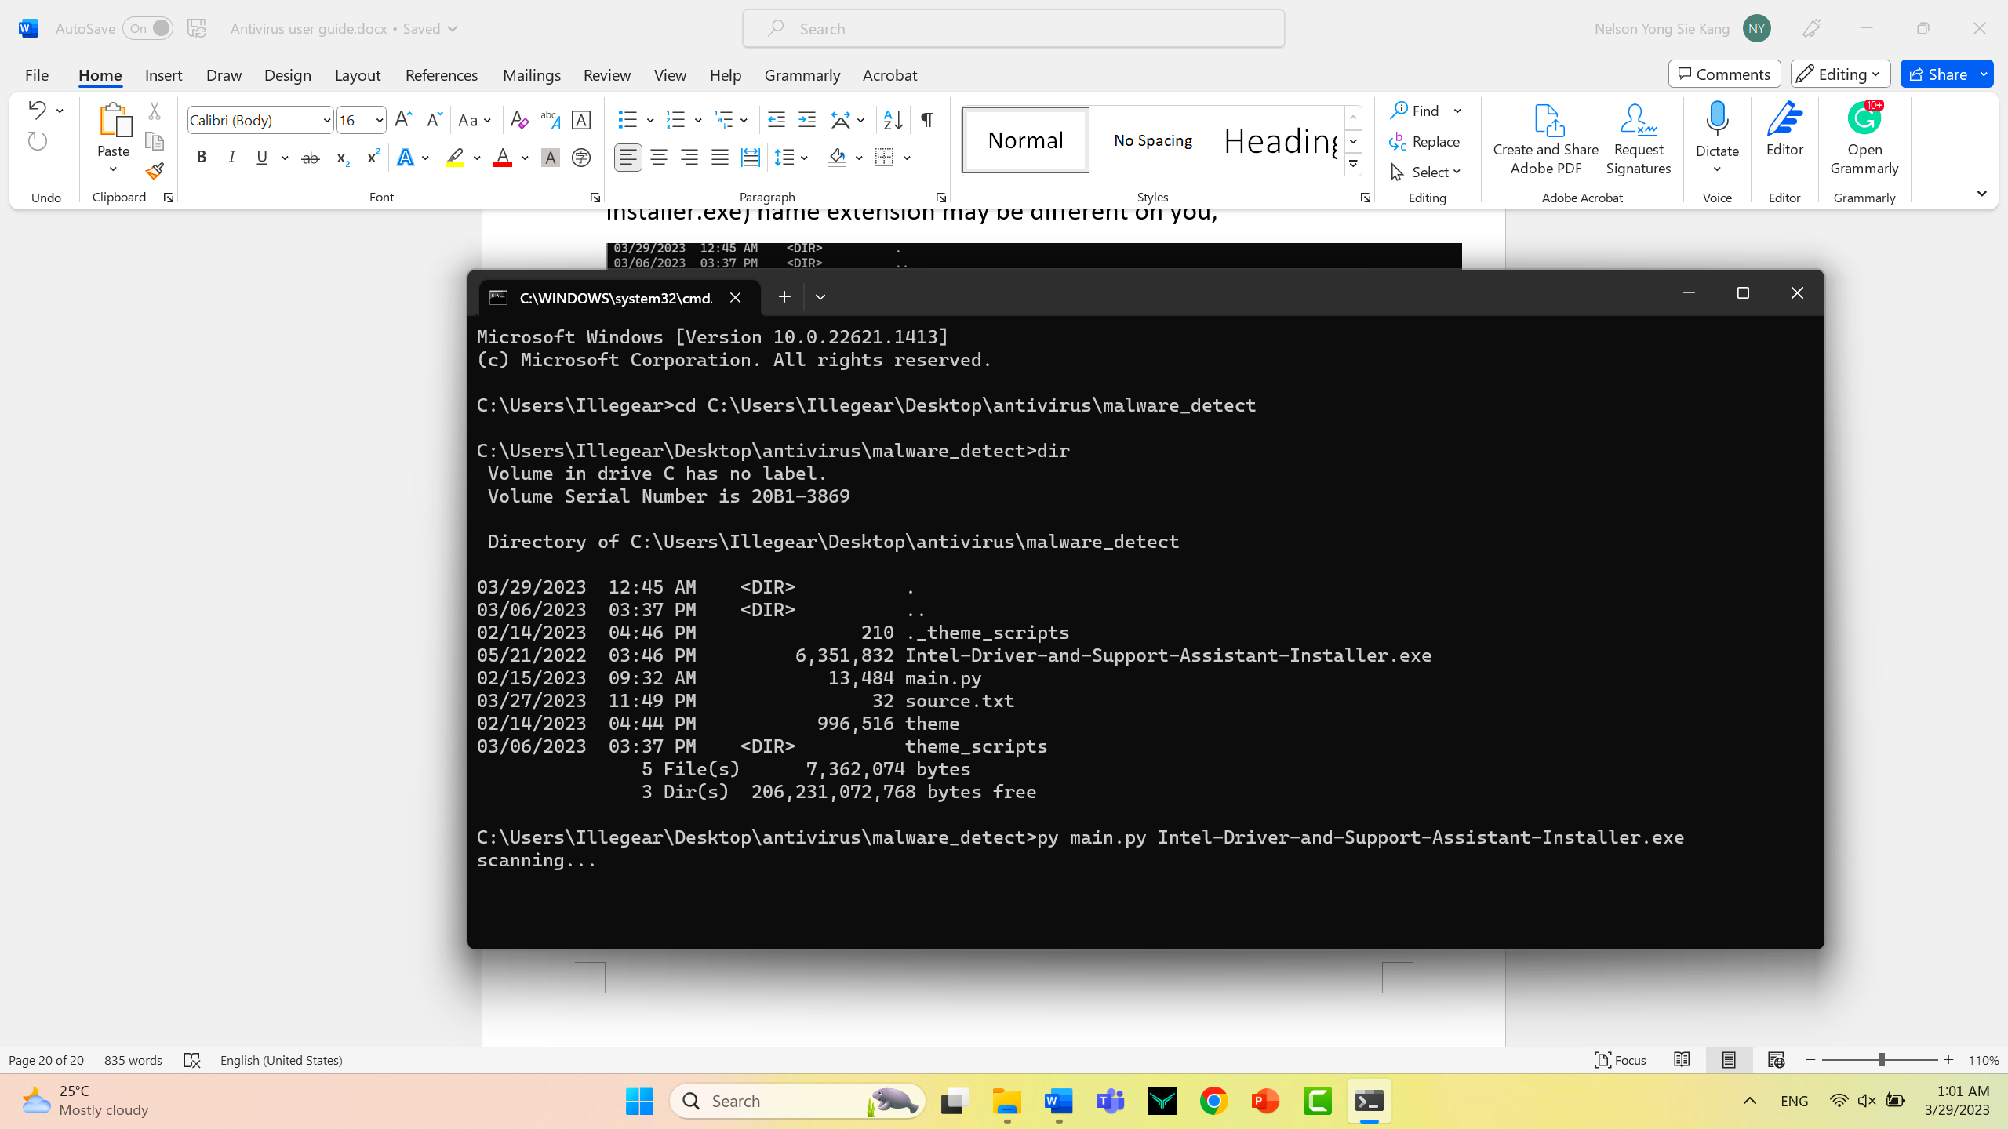

Step 16

This will be the situation if the file is not a malicious file then it will directly output uh analysis report back to the same folder just now.

Below is what it should be showing when it done scanning

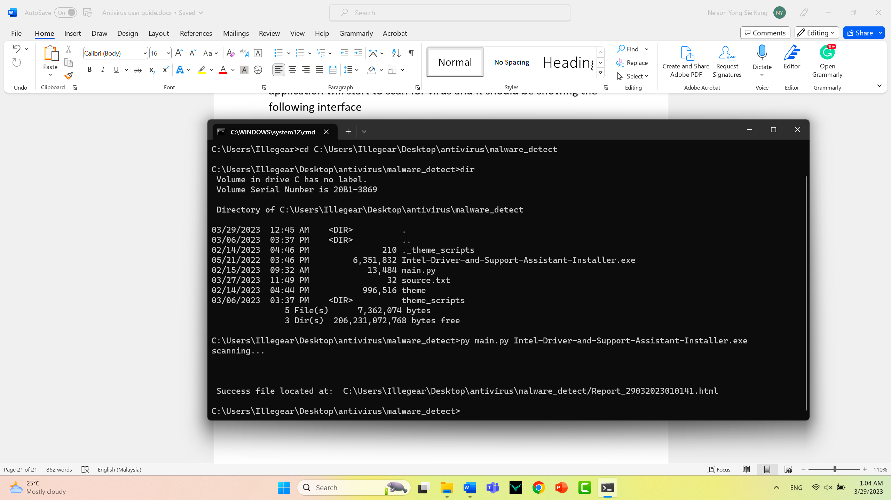

Step 17

now go back to the folder just now and you will see that there is a HTML file generated. You can double Click to open it

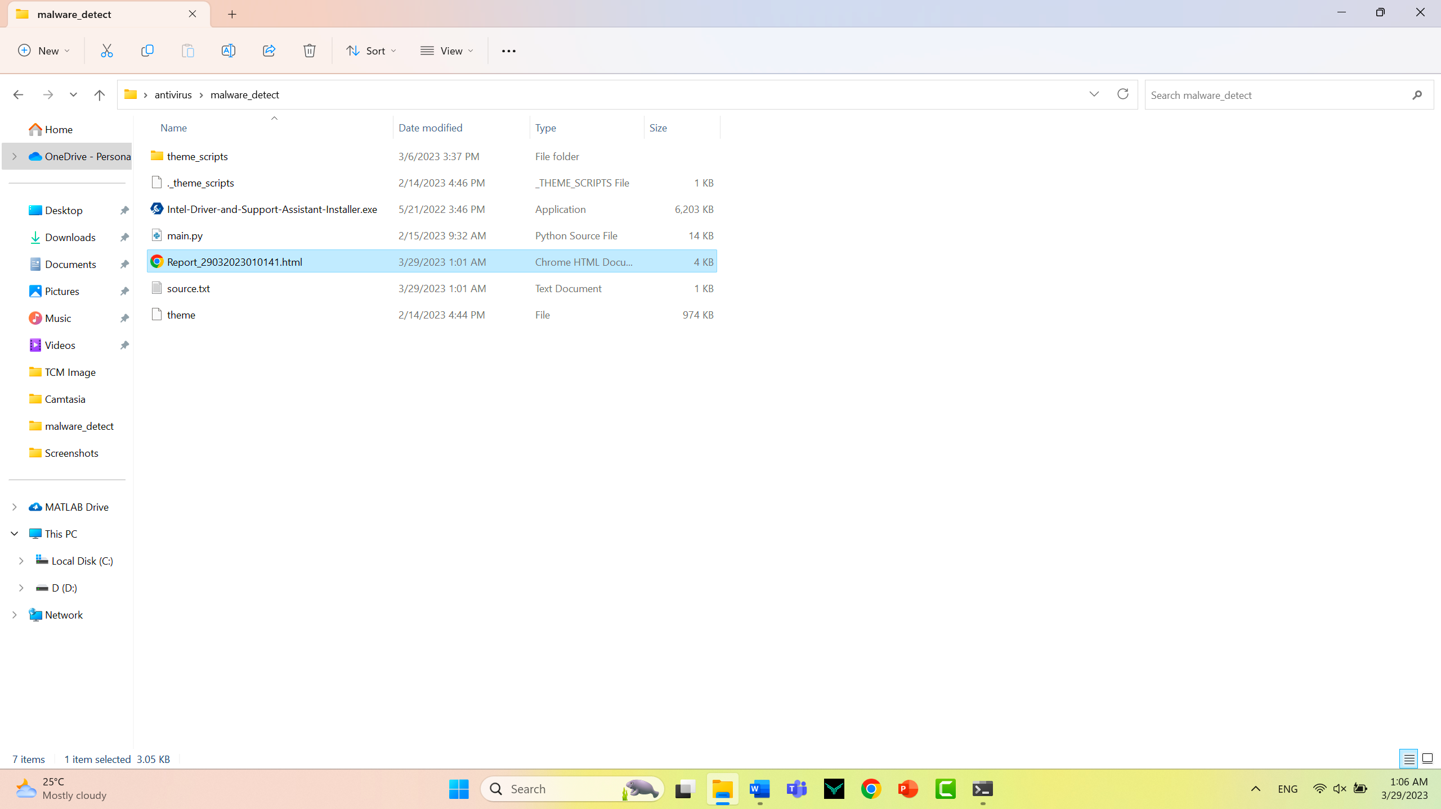

Step 18

Inspect the analysis report.

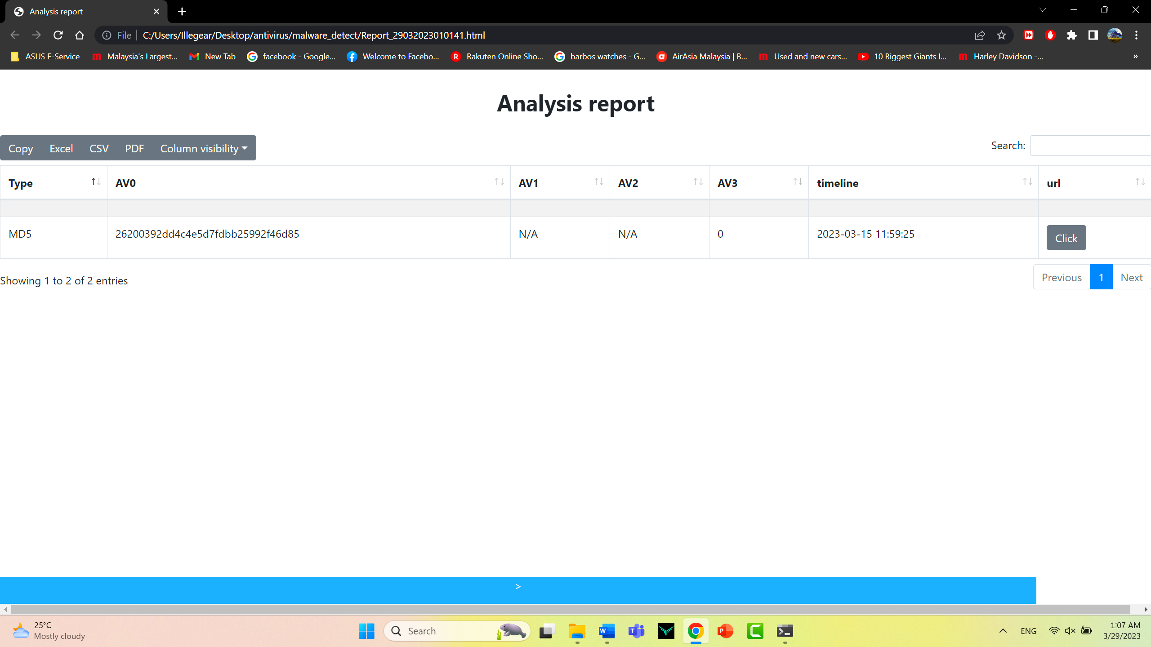

This is the situation where the file is not a virus.

Step 18

On the following button you can choose to export the analysis report onto a PDF or excel file

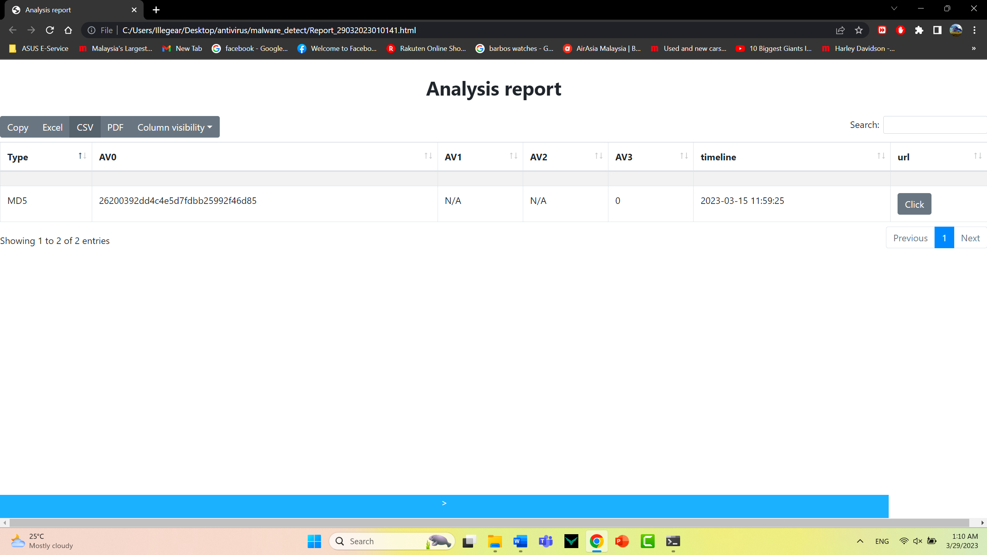

Step 19

Below will show the situation where if the file was detected as a malicious software.

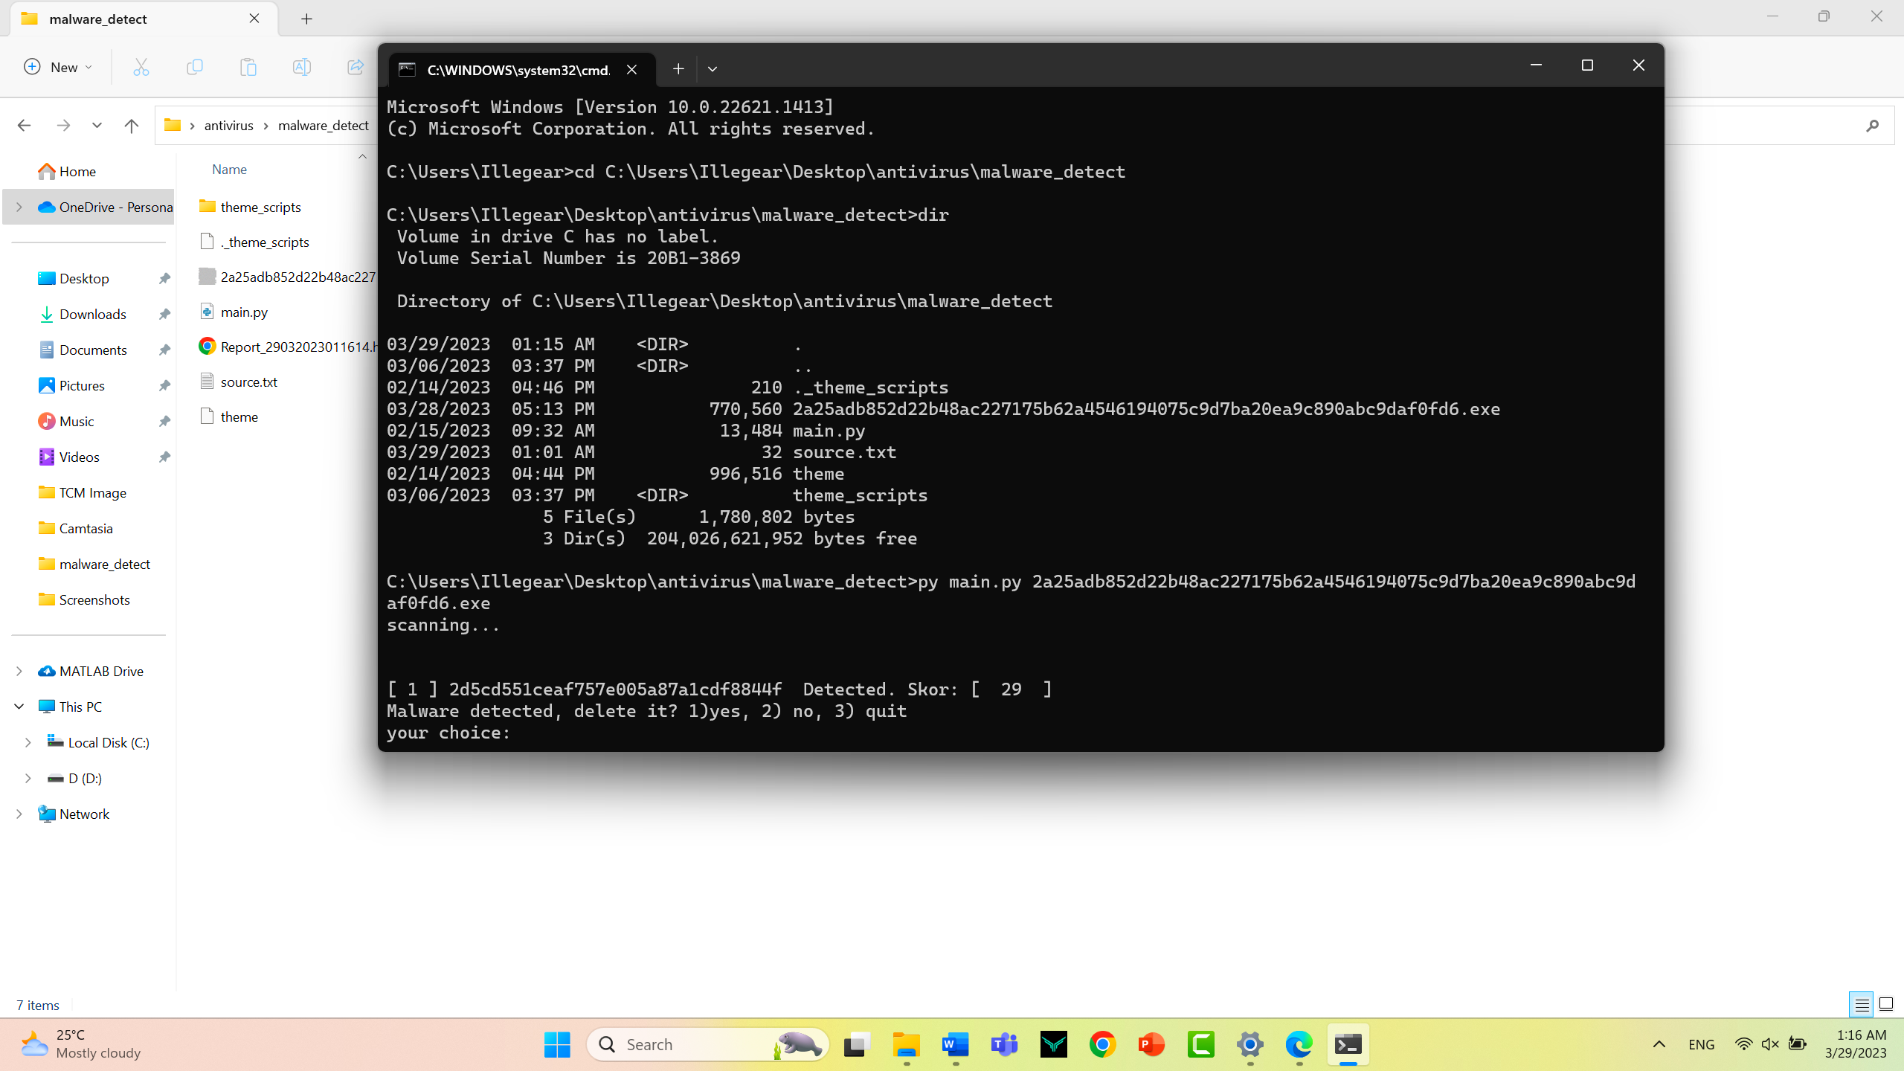

It will show a virus is detected and it will prompt you to weather delete the virus or keep the virus

Step 20

You can enter 1 to delete the virus, enter 2 to keep the virus or just enter 3 to quit the process. in my situation I will want to remove I enter 1 and press enter

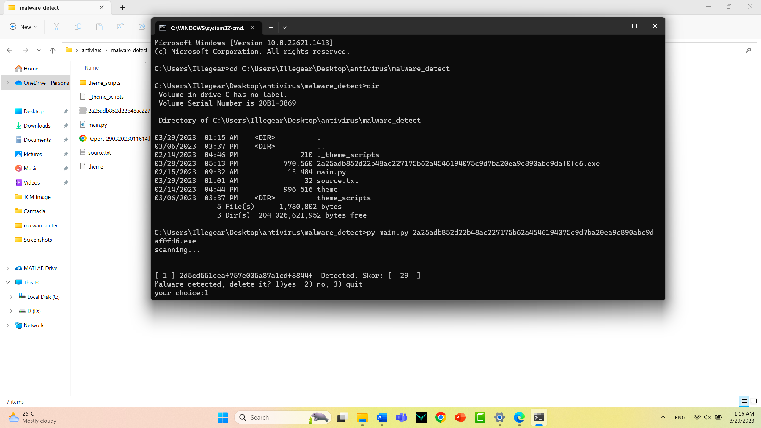

Step 21

After you enter 1 to remove the virus the virus will be deleted from your system

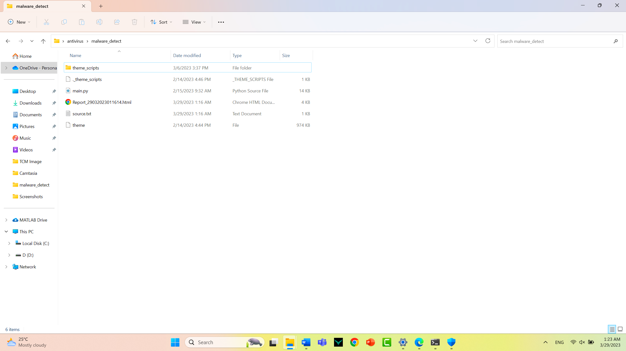

The virus is no longer in the system

Step 22

Now we can check the report by clicking open the HTML file

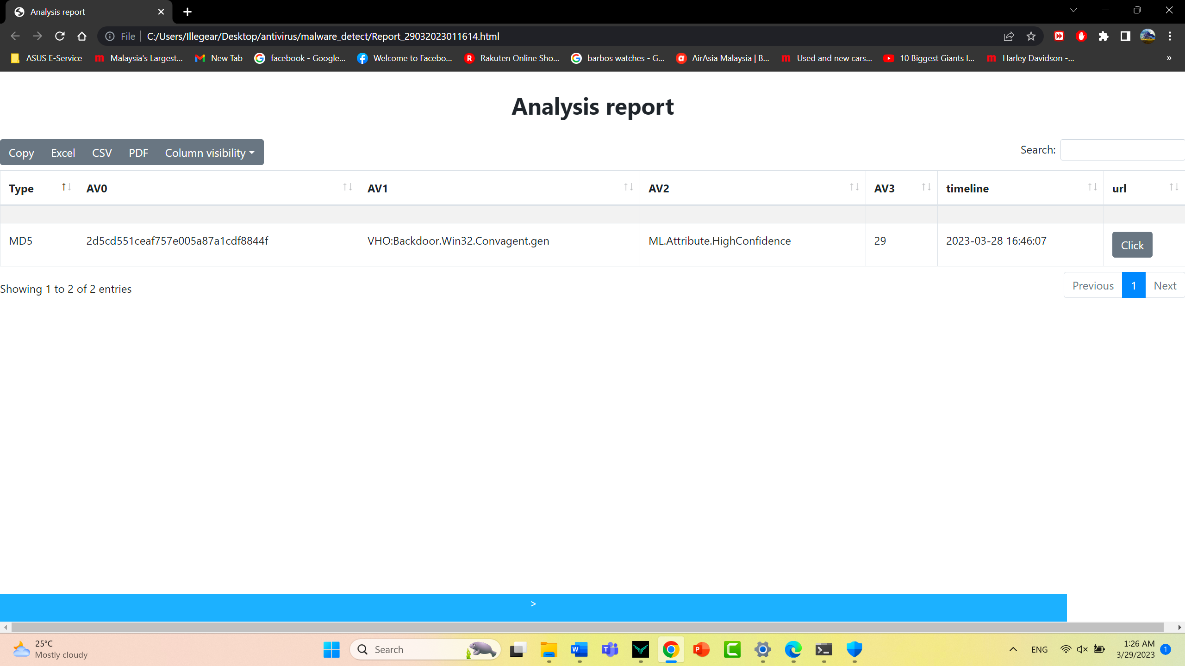

This is how it looked like when it detected a virus file, it showed the hash value of the file followed by the virus name detected by the famous antivirus engine Kaspersky and the second one is the Symantec.

Step 23

if you want to get the full detail of the virus report you can click on the button that will redirect you to the virus total website that has the full report of the virus.

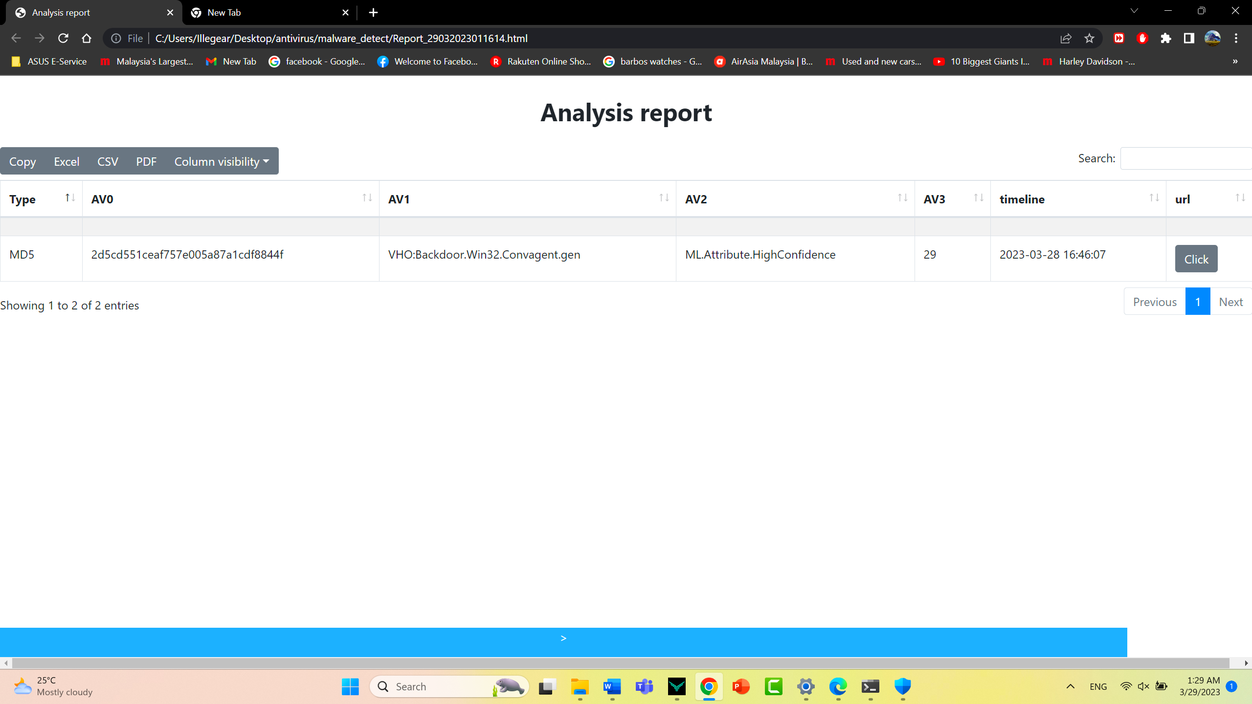

After clicking it he will be redirected to the virus of the website that contain the full report of the virus that you scanned just now.

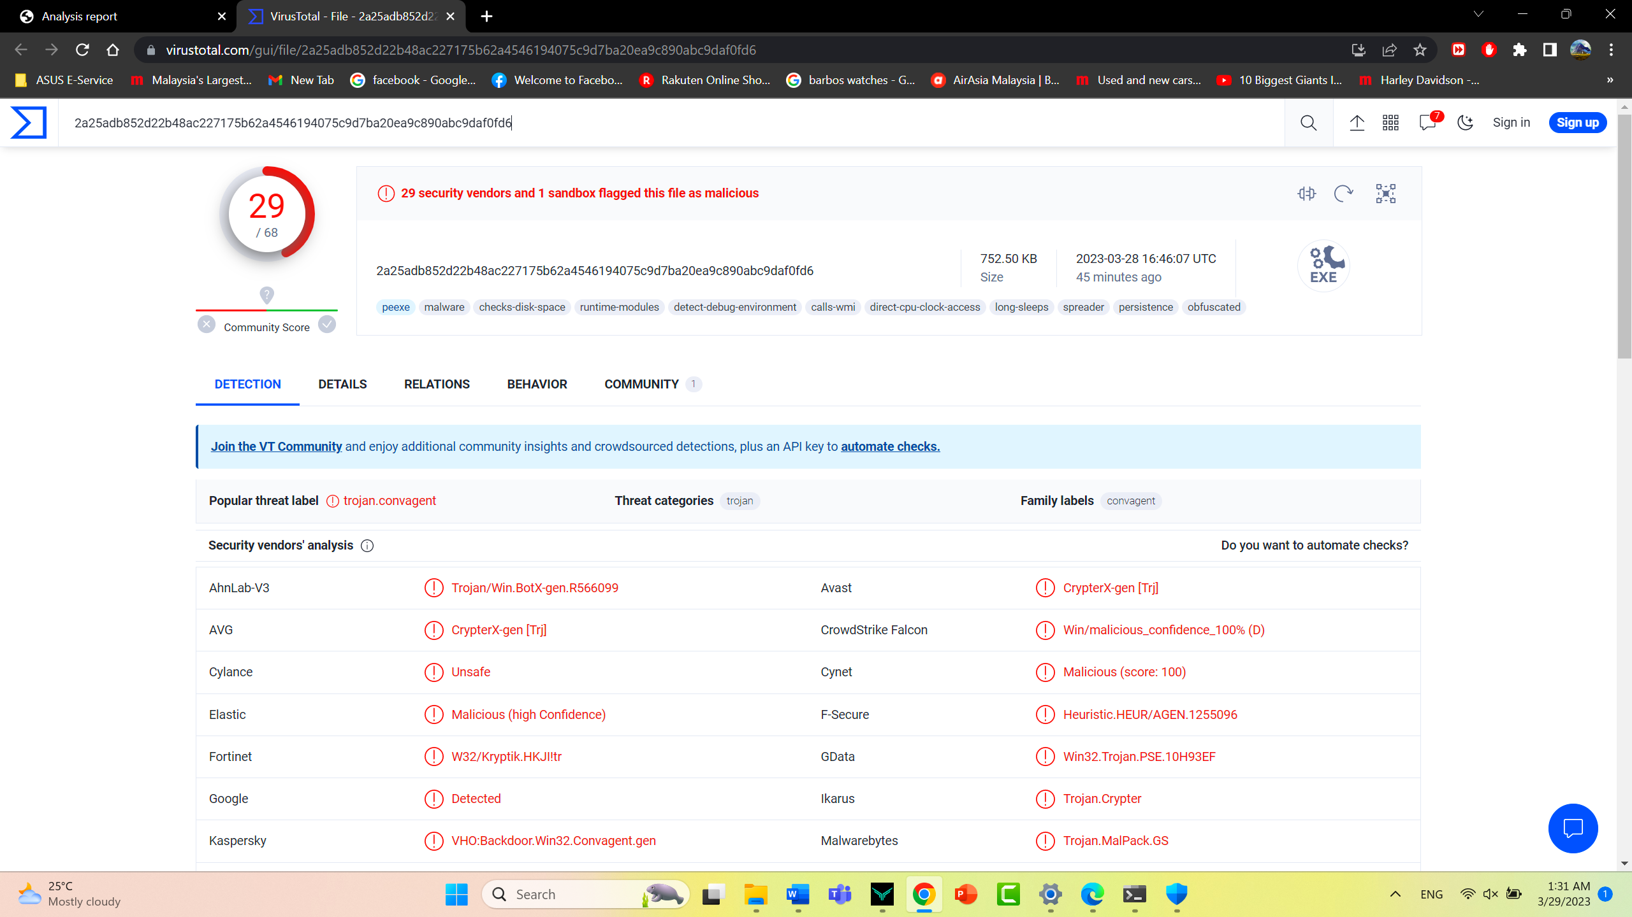

# User guide on running the application on Ubuntu system.

Step one

Firstly, download our applications from the GitHub website (<https://github.com/TT-cyberman/Anti-virus-Group3>)



Step 2

Download the zip folder which contain all of the necessary files of our applications.



Step 3

Save the file.

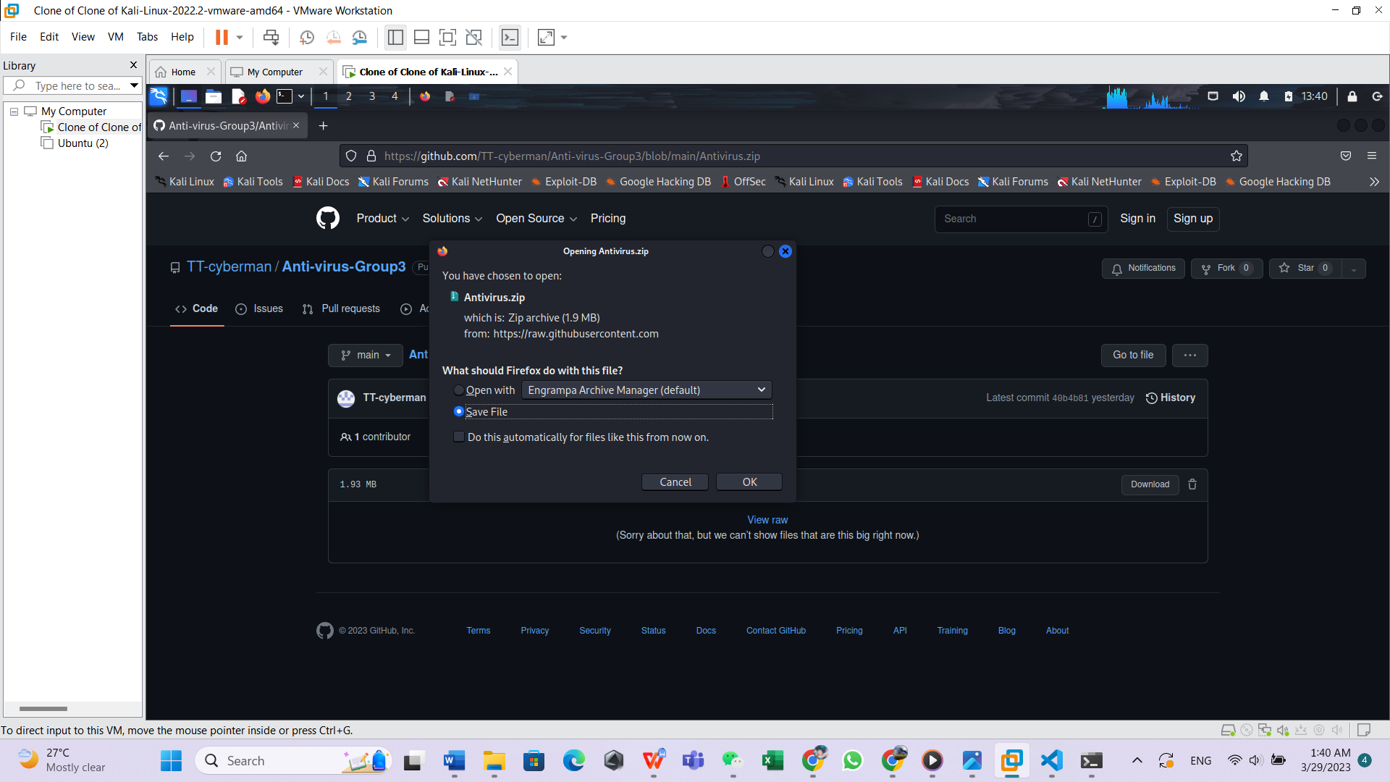

Step 4

After the file is download completed drag the file to the desktop

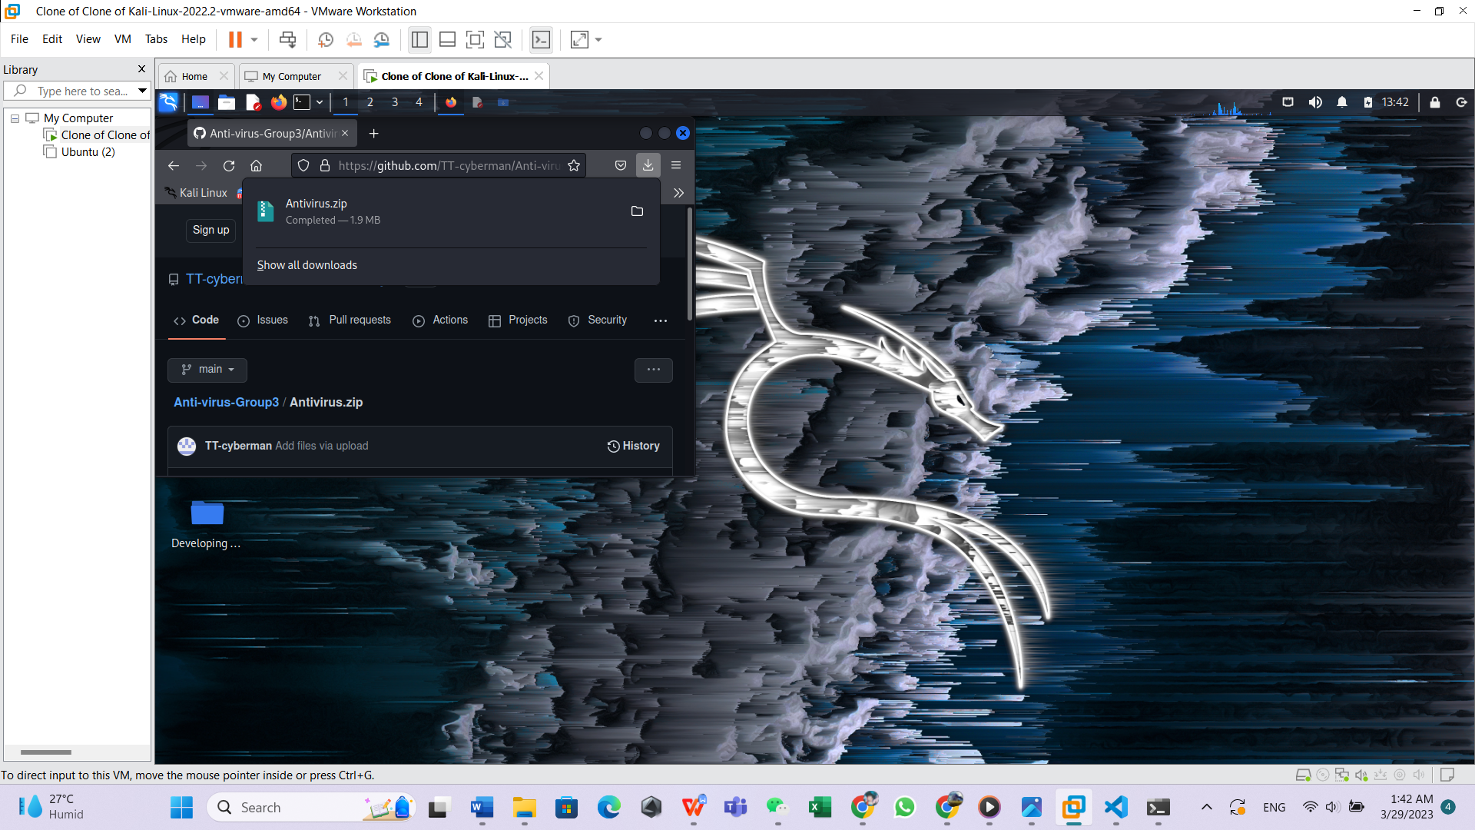

Step 5

Unzip the file and open it, and make sure the following file are shown

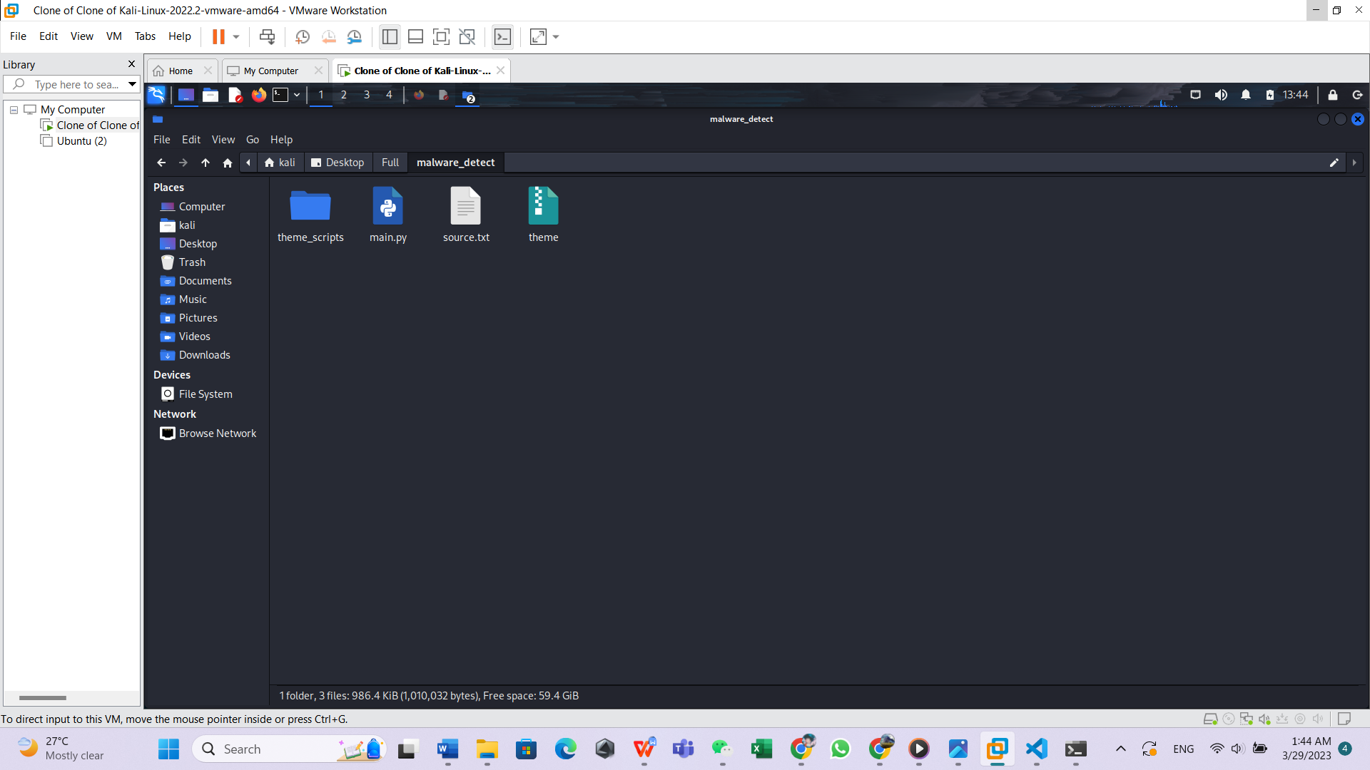

Step 6

In order to run the applications, right click on the folder. and then click open terminal here

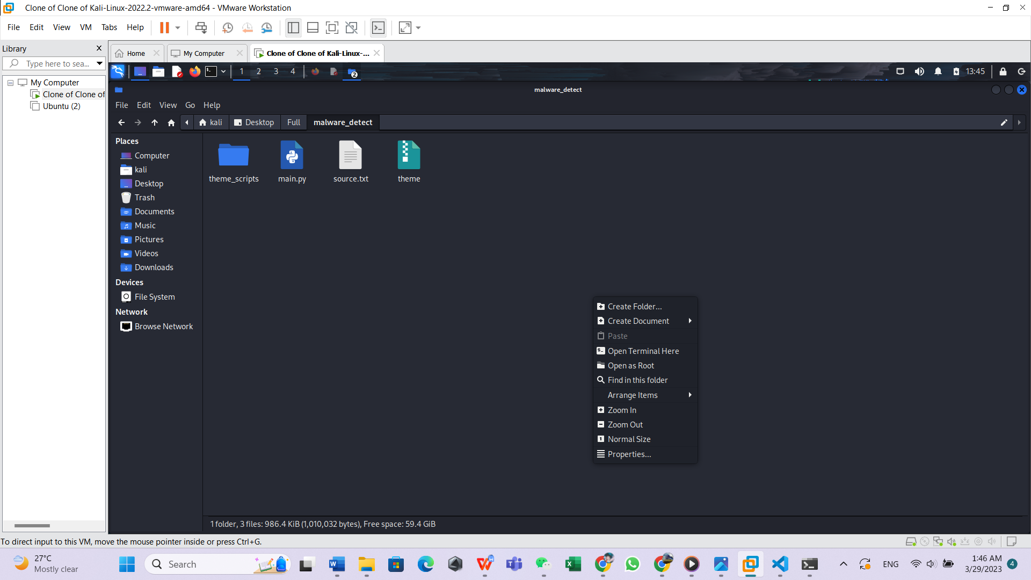

Step 7

A terminal will be open with the current directory path opened

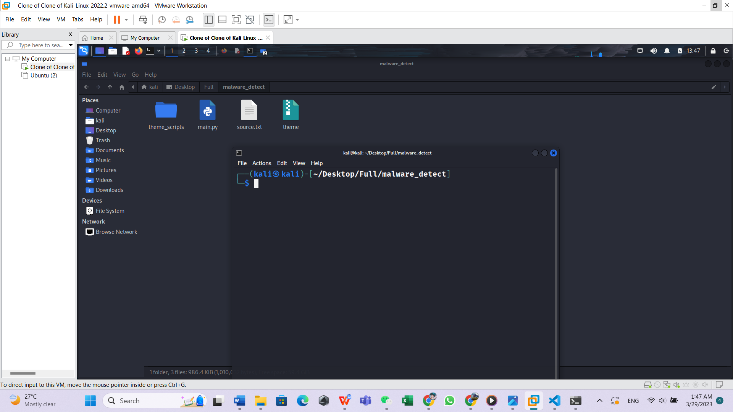

Step 8

Put the file that you wanted to scan into the same folder, in my case I wanted to scan this .EXE file

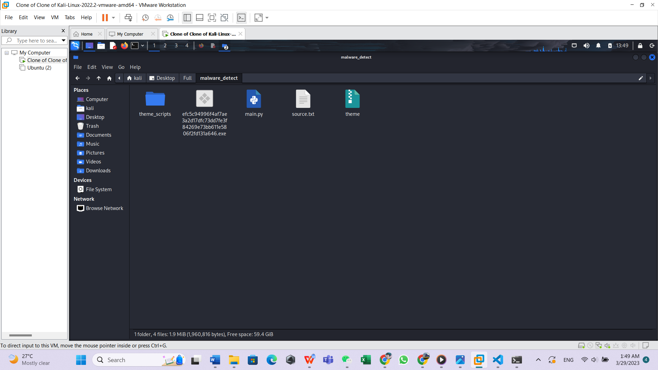

Step 9

now go back to the terminal you open just now and type the command (ls) then press enter

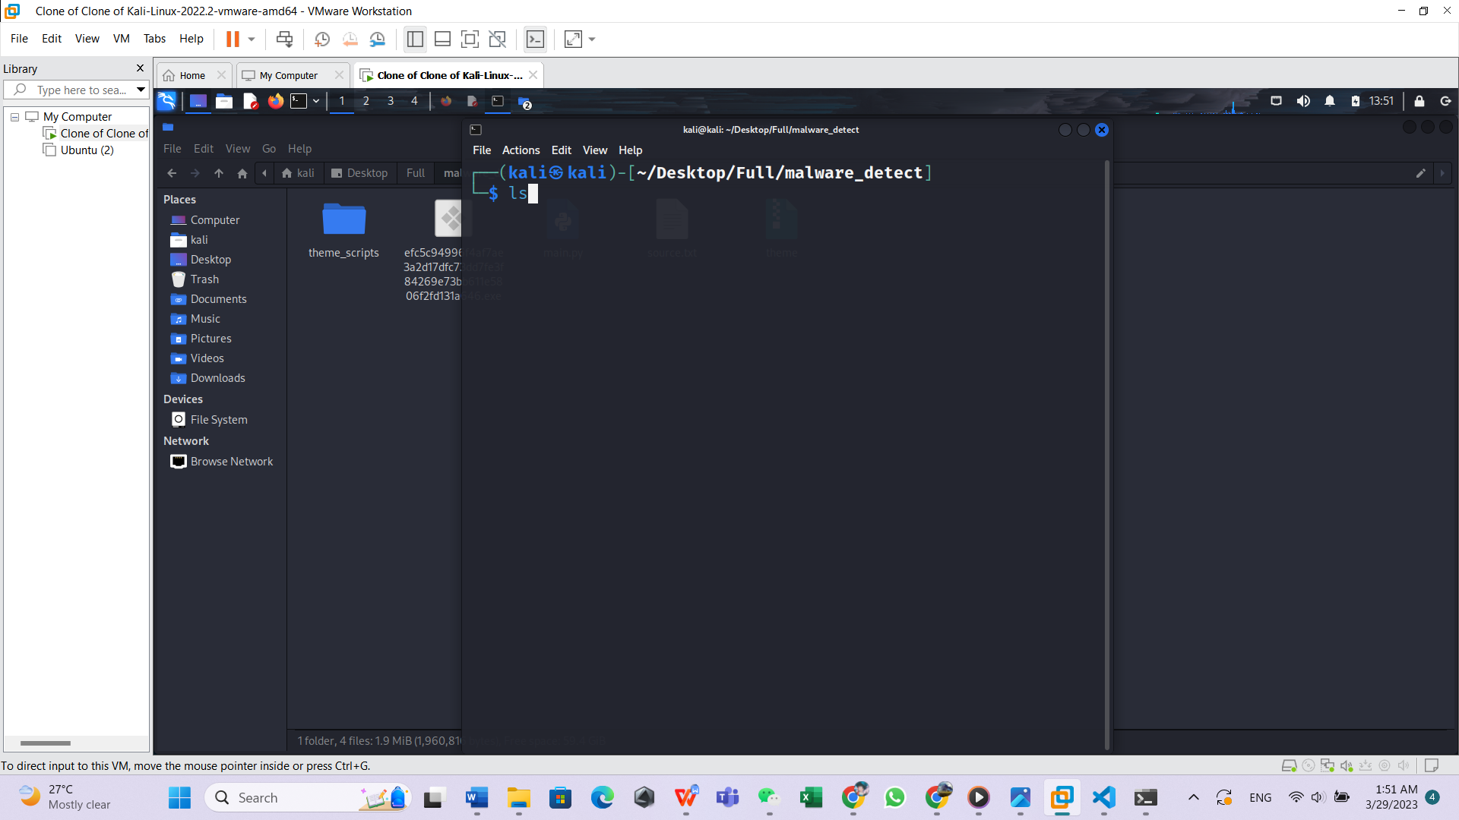

step 10

now the current directory will be shown.

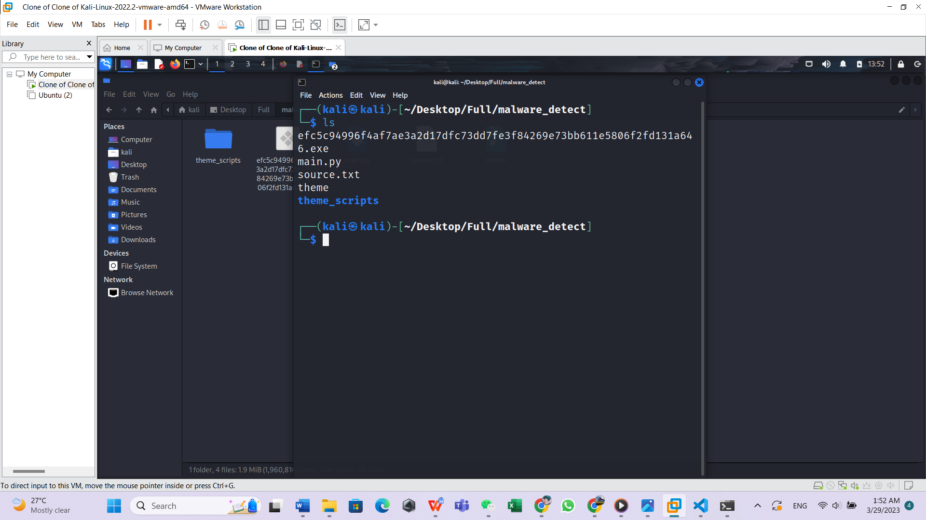

Step 11

now let's start to scan the file that we want.

Select the full name that you put just now then right Click to copy down the name

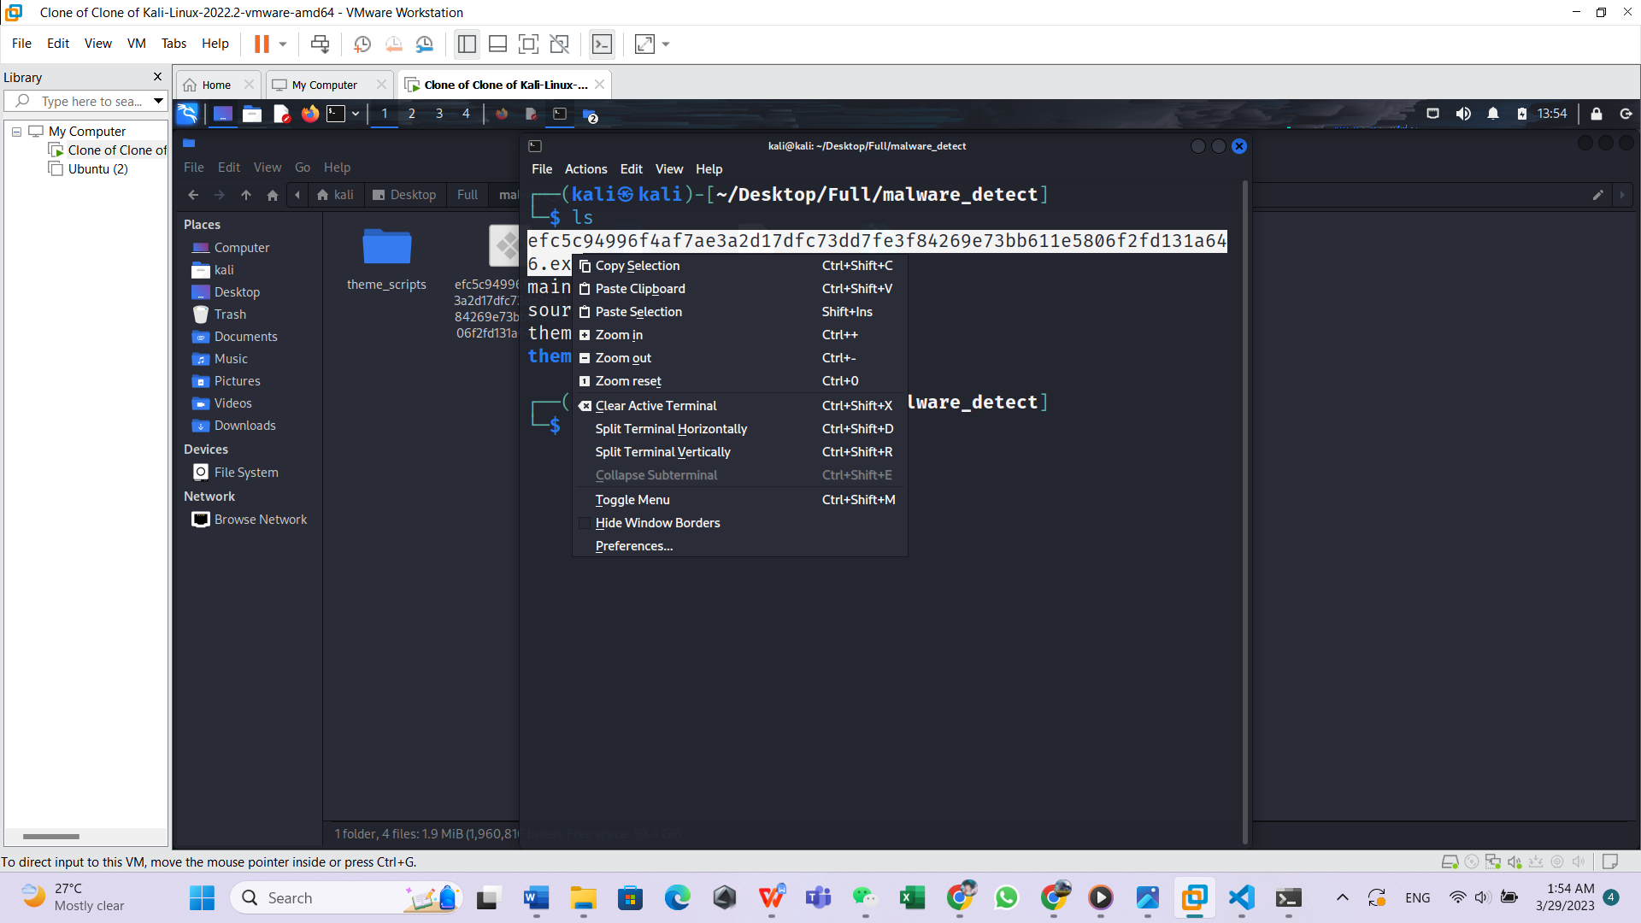

Step 12

now we will begin to type the command in order to run our application to scan the file

First type in (python3) in the terminal then space, second type in our application name (main.py) then space lastly paste down the file name that we copy just now into terminal, below will be example of the code

(python3 main.py efc5c94996f4af7ae3a2d17dfc73dd7fe3f84269e73bb611e5806f2fd131a646.exe)

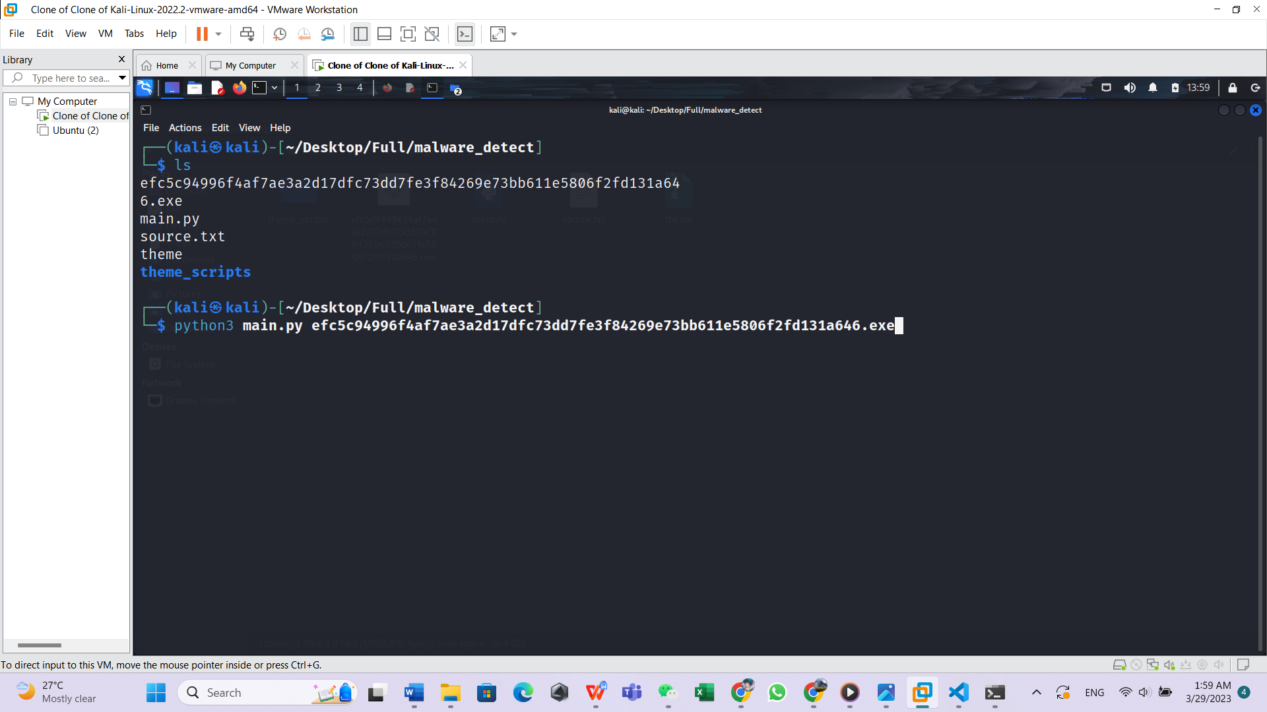

Step 13

press enter to start scanning.

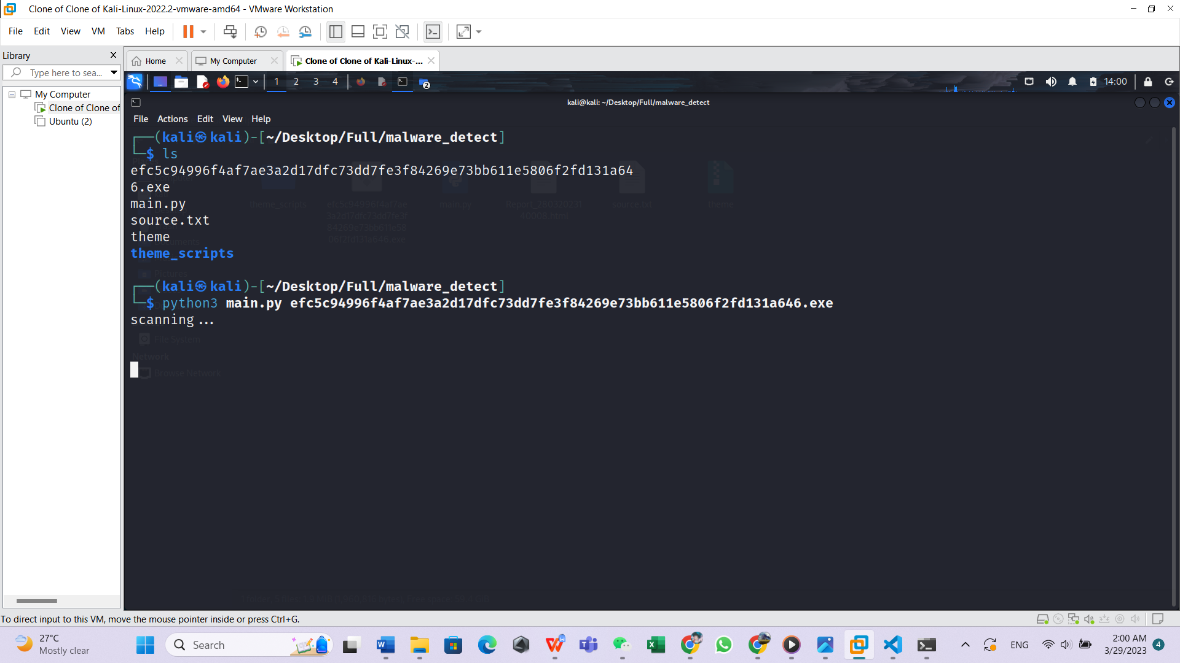

Step 14

now the application has successfully detected the virus it prompted the user for the next action

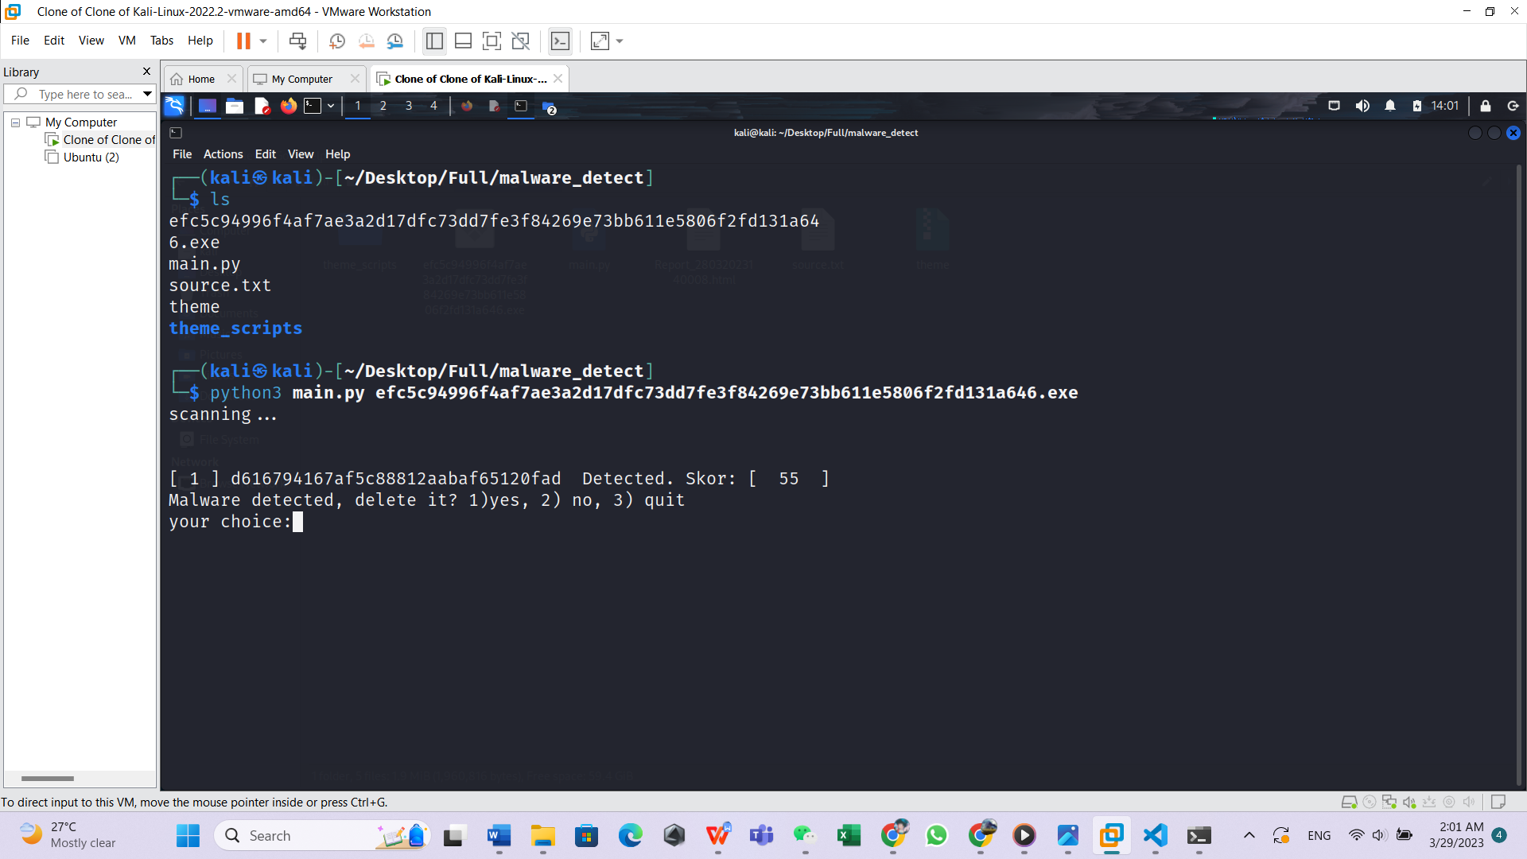

Step 15

now that you can choose to enter 1 to delete the virus, enter 2 to keep the virus or enter 3 to quit the program.

In my situation I wanted to I enter 1

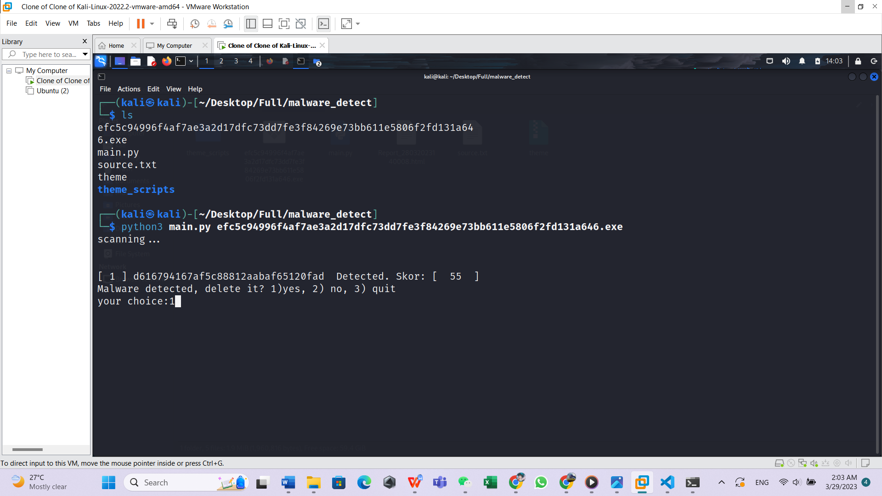

Step 16

Now that you can see the virus has been successfully removed from the system.

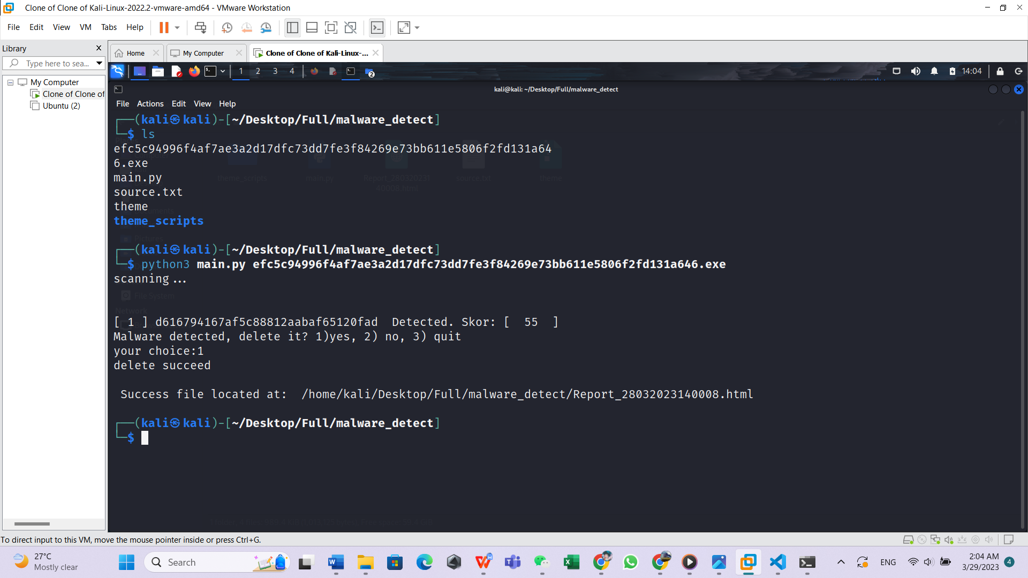

The file has no longer exists in the system

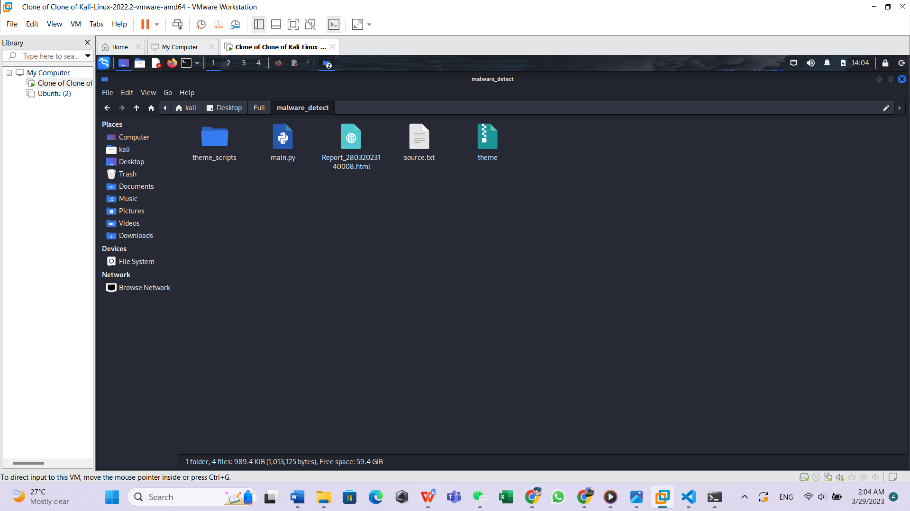

Step 17

Now that the virus has been successfully removed from the system and we can check the detail of the virus by clicking on the report that generate just now.

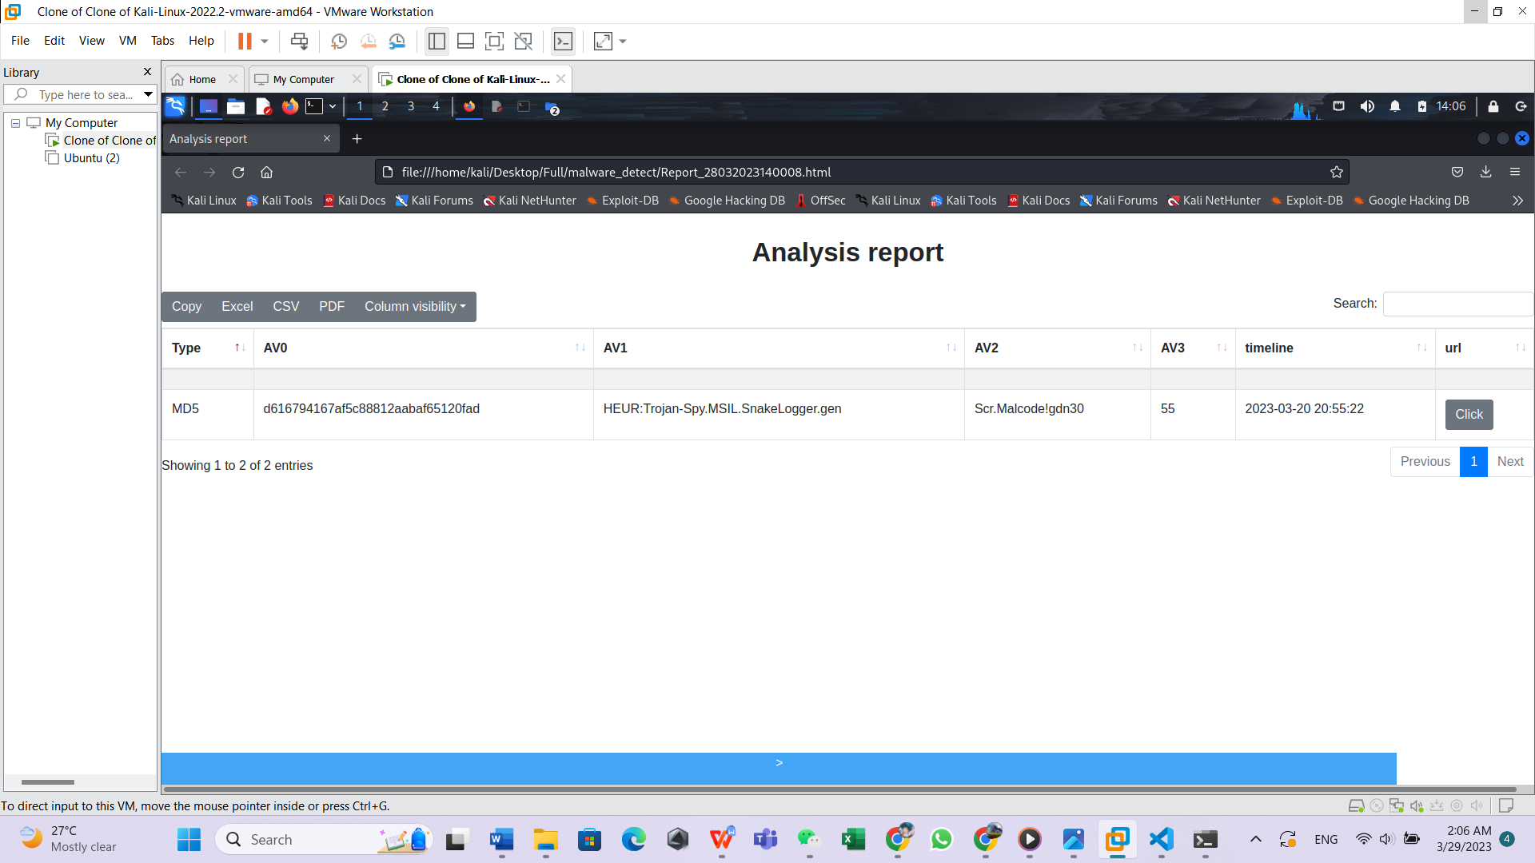

From the report we can see the hash being generated by the application, along with the name of the virus detected by the security vendor Kaspersky and Symantec.

Step 18

If you want to view the full report detail of the virus you can click on the URL then it will redirect you to the Virustotal website.

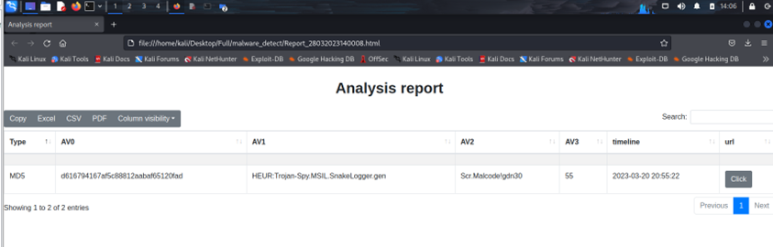

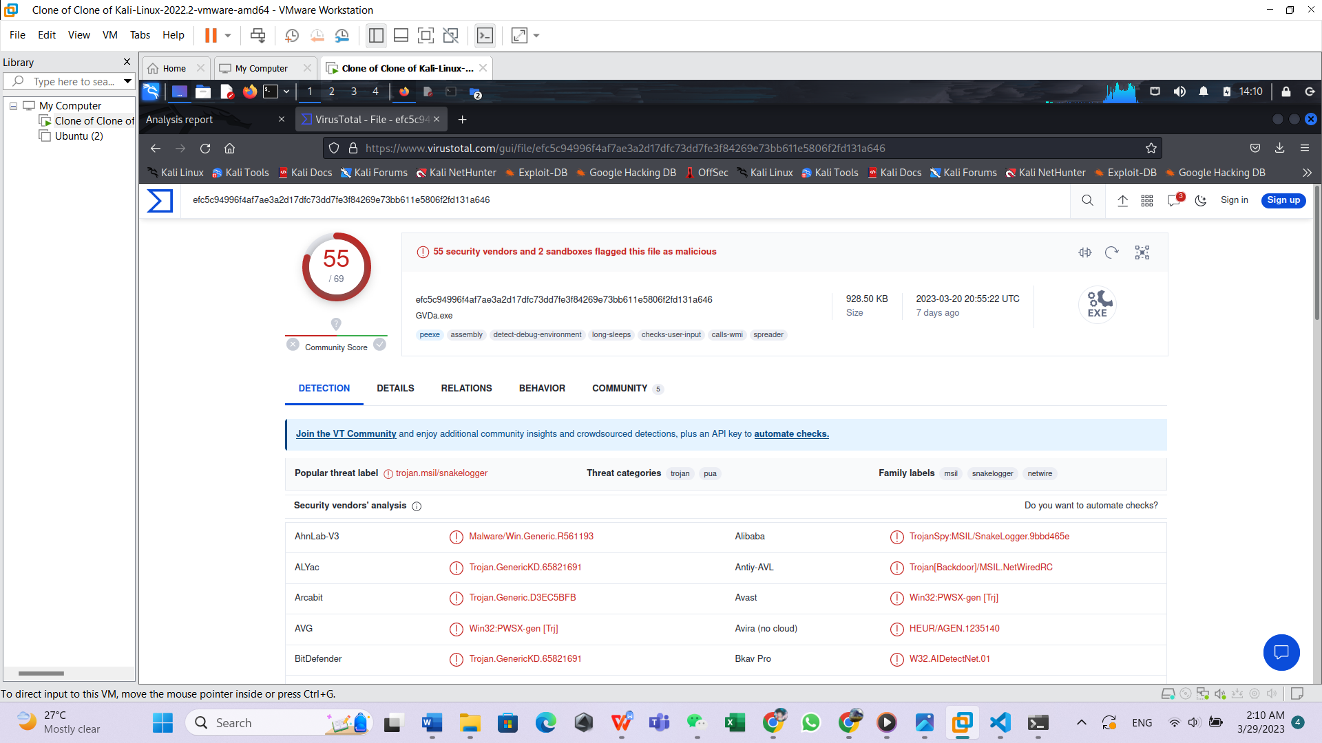

Step 19

if you want to export the analysis report you can click on the button to export the analysis report a different file type or you can just copy it.

